University of Arizona

Internal Medicine



Intern Survival Guide

2021-2022

**Preface**

This UAIM Manual was created with the purpose of improving the efficiency of residents and to help residents familiarize and maneuver around the complexities of the health-care delivery system. It will require the input and feedback of all house staff as we aim to improve the contents of this mini-manual for it to better serve its purpose. We hope this guides you throughout your medical journey. **This is only a guide and clinical judgment supersedes all.**

**Best of luck,**

Justin Lee (2015)

Alana Dembitsky (2015)

Laith Ghazala (2015)

Jennifer Segar (2015)

Ryan Wong (2018)

Anthony Witten (2018)

Joao Paulo Ferreira (2018)

Richard Young (2019)

Morgan Bailey (2020)

Elaine Cristan - Pulmonary Critical Care (2018)

Bhupinder Natt - Pulmonary Critical Care (2018)

If you have any feedback, please email **mchacon@arizona.edu**

Feedback is greatly appreciated, and may include:

* Important and handy information that the handbook should contain
* Correction of errors in the information provided

**Acknowledgements:**

Special thanks to Drs. Justin Lee and Anthony Witten for passing down the Intern Survival Guide that served as the foundation of this newest edition.

Also a huge gratitude to Dr. Bhupinder Natt and Dr. Elaine Cristan for providing extensive input into this revised edition.

Letter from your ICU Faculty:

Medical ICU is an exciting and educational rotation for most residents, whether or not becoming an Intensivist is their career goal. There is immense learning potential and a lot that can be easily applied outside of the ICU.

The expectations for residents during the ICU are to learn and contribute to inpatient care, assist and perform common bedside procedures, be involved in family meetings and conversations, and attend didactic teaching sessions. Other duties and expectations may present themselves. Please refer to the residency rotation expectation documents.

ICU care is highly dependent on team approach. A typical team consists of attending physicians, fellows, residents, bedside nurses, pharmacists, respiratory therapists, physical therapists, social workers, nutritionist, and many other ancillary specialties. Everyone has a common goal of providing excellent patient care and there is no role for conflict or competition within the team. Respect others and their opinions.

This handbook is here to guide you to some important aspects of the rotation but is not an exhaustive source. We hope you have fun, learn and be an active contributing member of our team.

Sincerely,

Dr. Elaine Cristan, MD and Dr. Bhupinder Natt, MD

**INDEX**

1. **BUMC-T**
   1. Extensions 2-4
   2. Pagers/Door Codes/Local Hospitals 4-5

Transfer Requirements

1. Skilled Nursing Facility (SNF) 6
2. Acute Inpatient Rehab 6-7
3. Long Term Acute Care (LTAC) 7
4. Hospice 7
5. Inpatient Psychiatry 8

UMC Prescriptions 8

1. Home BIPAP 8
2. Home CPAP 8-9
   1. Durable Medical Equipment (DME) 9-10
   2. Home Enteral Feeding 10
   3. Home Health 10-11
   4. Home Infusion 11
   5. Home Nebulizer 11-12
   6. Home Oxygen 11-12
   7. Home TPN 13
   8. Home Trach Care 13
   9. Negative Pressure Wound Therapy 14

UMC FAQ 14

1. **VA**
   1. VA Extensions 16-17
   2. Difficult to Find Orders 17-18

VA Discharge Preparations 18-21

1. Home BiPAP
2. Home CPAP
3. Home Oxygen
4. Community Living Center placement
5. Tracheostomy patient
6. Home antibiotics
7. Home enteral feeding

VA Hospice and Palliative Care20-21

VA FAQ 21

1. **TMC**

Extensions 23

TMC FAQ23-24

1. **Approach to General Medicine 25**
   1. Fever 25-28
   2. Insomnia 28
   3. Tachycardia 29-31
   4. Bradycardia 32-35
   5. Nausea 36
   6. Pain 36-37
   7. Bowel Regimen 37
   8. Hypertension 37-38
   9. Hypotension 39
   10. Hypoglycemia 39
   11. Hyperglycemia 39-40
       1. HHS 40 & 43
       2. DKA 40-42
   12. Altered Mental Status 44
   13. Seizures 45
   14. Chest Pain 45-46
   15. Shortness of Breath 46-48
   16. Asthma 48
   17. COPD 48
   18. Comfort Care Medications 49

## Electrolytes

* 1. Hypokalemia 48-50
  2. Hyperkalemia 50
  3. Magnesium 50-51
  4. Hypocalcemia 51
  5. Hypercalcemia 52
  6. Hyponatremia 52-55
  7. Hypernatremia 56
  8. Hypophosphatemia 56
  9. Hyperphosphatemia 57

**IV Fluids** 57-58

1. **Infectious Disease**
   1. Antibiotics 59-64
   2. Pneumonia 64
   3. Antibiotics Coverage 65
   4. Sepsis 66-68
   5. Hemodynamic Parameters 69
   6. Vasoactive Agents 70-72
2. **Cardiology**
   1. Shock 72-73
      1. Cardiac Drips 74-76
   2. Basic EKG Interpretation 77-79
3. **Hematology** 79-83

DVT/PE, Oral Anticoagulants, DIC, HIT

* 1. Blood Components 83-84
  2. Transfusion Reactions 84

1. **ICU**
   1. Organization of Notes 85-87
   2. ICU Prophylaxis 87-88
   3. Supplemental Oxygen 88-89
   4. Respiratory Failure 89-90
   5. Non-Invasive Positive Pressure Ventilation 90-91
   6. Invasive Mechanical Ventilation 91-94
   7. Acute Respiratory Distress Syndrome 94-96
      1. High PEEP/Low FiO2 95
      2. NIH Predicted Body Weight: Tidal Vol 96
   8. Troubleshooting High Peak Pressure 97
2. **Acid/Base** 98-99
3. **Procedures**
   1. Central Lines 100
   2. Paracentesis 100
   3. Lumbar Puncture 101
   4. Thoracentesis 102
   5. Pleural Effusions 102-103
   6. Chest Tube Management 103-104
4. Sedation 105
5. Paralytics 106
6. ABCDE Bundle 106-107
7. ICU References 108
8. How to Call A Consult 109
9. Antibiotic Coverage 110
10. ACLS Algorithms 111-114

**Chief Information:**

Eric Brucks: Scheduling |(808) 421-8252| [bruckses@arizona.edu](mailto:bruckses@arizona.edu)

Sumana Veeravelli: TMC/Clinic | (602) 516-6251| [3summy@arizona.edu](mailto:3summy@arizona.edu)

Martin Chacon: UMC |(214) 934-1474| [mchacon@arizona.edu](mailto:mchacon@arizona.edu)

Shishir Rao: VA |(925) 336-6167| [shishirrao@arizona.edu](mailto:shishirrao@arizona.edu)

**Scheduling Requests:** [bruckses@arizona.edu](mailto:bruckses@arizona.edu)

**Elective Requests**: [bruckses@arizona.edu](mailto:bruckses@arizona.edu) or [3summy@arizona.edu](mailto:3summy@arizona.edu).

Schedule and Elective changes are not guaranteed and are difficult to accommodate with less than 2 months’ notice.

**Clinic Concerns:** [3summy@arizona.edu](mailto:3summy@arizona.edu)

**Amion:** [www.amion.com](http://www.amion.com) 🡪 Password uaim

**New Innovations:** [www.new-innov.com](http://www.new-innov.com) 🡪 institution: ua

Log duty hours daily

Log Procedures as soon as completed

Complete Evaluations truthfully and soon after rotation

Log Scholarly Activities and Projects

Location for Ground Rules, Conference Attendance Tracking

**IM Office Contacts**

Kerith Lisa: IM Program Manager | kerith@arizona.edu

Julie Forte: Financial, Reimbursement, Travel Authorization | jforte3@arizona.edu

Monica Jimenez: New-Innovations, Away Electives, notary public

| mjimenez413@arizona.edu

Jodi Peters: VA Resident Liaison | jodi.peters@va.gov



**BUMC Numbers**

* Paging an old 4 digit pager: Dial #80, then 4 digit pgr number, wait for prompt dial your extension (4-xxxx) * your pg number. To page from cellphone, dial “694-4480”.
* How to dial extension? Within hospital dial 4-(xxxx), out of hospital 520-694-xxxx

|  |  |  |
| --- | --- | --- |
| Units | Extensions | Fax |
| 3E | 4-5247 |  |
| 3NE | 4-7166 | 694-9479 |
| 3NW | 4-7656 | 694-9478 |
| 4W | 4-4227 | 694-9488 |
| 4NE | 4-2680 | 694-6489 |
| 4NW | 4-7660 |  |
| D2N | 4-3260 | 694-1052 |
| D3N | 4-3400 | 694-0188 |
| D5 | 4-7453 |  |
| D6N | 4-7376 |  |
| D6W | 4-7612 |  |
| 1W/CDU | 4-7521 |  |
| ER | 4-7547 |  |
| Physician Resources | 4-5868 |  |
| 9NS/EW |  |  |
| 8NS/EW |  |  |
| 7NS/EW |  |  |
| 6NS/EW |  |  |
|  |  |  |

|  |  |  |  |
| --- | --- | --- | --- |
| Meds Appt Scheduling | 694-0111 | Medicine captain | 446-1000 |
| Bed Control | 4-4600 | **Team 1-2** | 446-1506 |
| General apt line for UMC/UPH (MD only) | 4-4500 | **Team 3-4** | 446-1525 |
| Cath Lab | 4-6156 | **Team 5** | 446- |
| Cards Nuclear | 4-7411 | **ICU CONSULT** | 446-3099 |
| Cancer center (North Campus) | 4-CURE | **CCU** | operator |
| Dialysis | 4-7176 | OR desk | 4-6120 |
| Echo | 4-6559, 4-7499 | PACU | 4-7510 |
| EEG | 4-6112 | Clinical Path | 4-5624 |
| Exercise Stress Lab | 4-7248 | Surg Path | 4-7877 |
| GI Dept | 626-6119 | Cytology | 4-7139 |
| Help desk | 4-4357 | Inpat. Pharm | 4-6577 |
| Lab | 4-6601 | O/P Pharm | 4-7048 |
| Lab – Micro | 4-6282 | Poison Ctl | 6-6016 |
|  |  | Pulm Lab | 4-6663 |
|  |  | PICC team | 4-4218 |

|  |  |
| --- | --- |
| Radiology Reading Room | |
| CT | 4-7053 or 4-7065 |
| MRI | 4-6760 |
| IR | 4-2379 |
| US | 4-6918 |
| Xray | 4-5027 |
| Radiology scheduling | 4-4886 |
| Vascular lab | 4-6694 |
| Ultrasound lab | 4-6918 |
| Cards Nuclear | 4-7400 |

**Getting consult** **pager/extension** **numbers**:

1. “Physician Resource” A.K.A Transfer Center – 4-5868 +2
2. Search “http://bumgt.qgenda.com/” from a Banner/UMC computer or when logged in through the portal. Amtelco is being phased out.

**Consults with Split Services**

**GI**: General v Hepatology v Biliary/Interventional

**Nephrology**: Floor v ICU v Transplant

-- AKDHC Patient, call 520-529-6500 for answering service

--**please note South West Kidney is covered by the University Nephrology Service

**Infectious Disease**: regular ID vs transplant ID

**Neurology**: General Neurology v Stroke

**All Surgical Services**: Access "Surgery" and dropdown menu

|  |  |  |
| --- | --- | --- |
| **Surgery** | **Pager** |  |
| Trauma/Gen Surg | Contact operator (4-0111) | acute events, needing fast surgical intervention |
| Surgical Oncology | Contact operator | breast surgery, colorectal surgery, endocrinology surgery, LN biopsy |
| Hepatobiliary Sx | Covered by Txp or Surg Onc | |
| Plastic Surgery | Contact operator | decubitus ulcer needing bone biopsy, flap rotation/graft |
| ENT | Contact operator | laryngeal tumor/abscess, mouth/tongue/throat problems |

|  |  |
| --- | --- |
| Codes | |
| ICU Call Room | Badge access |
| Tubing stations | 243 or 12345 |
| CCU 6606 a/b | 421 |
| Diamond Codes (D2N/D2W/D3N/D3W) | 1492/1857/0214/5184 |
| Resident work room (3rd floor) | 9874 |
| IM Resident Lounge (6th Floor) | 9874# |

|  |  |  |  |
| --- | --- | --- | --- |
| Local Hospitals | | Out of Tucson Hospitals | |
| Northwest ER | 742-9000 | **Benson** | 520-586-2261 |
| NW Oro Valley | 901-3500 | **Holy Cross** | 520-285-3000 |
| St Joseph’s | 296-3211 | **Sierra Vista** | 520-458-4641 |
| St Joseph’s ER | 873-3840 | **Maricopa Burn Center** | 602-344-5726 |
| St Mary's | 622-5853 | **Phx General** | 480-879-6100 |
| St Mary's ER | 872-4901 | **Phx St Joe's** | 602-406-3000 |
| TMC | 327-5461 | **Phx Good Sam** | 602-239-2000 |
| TMC ER | 327-5700 | **VA Hospital** | 792-1450 |
| TMC Med Rec | 324-5165 |  |  |

**BUMC Transfer Requirements**

**Transfer – Skilled Nursing Facility Placement (SNF)**

Place Case Management Consult for SNF placement

* Services must be skilled and need 24h care
  + Physical rehab (PT/OT), IV Abx, wound care
    - Any elderly patient that is not able to stand up without assistance should have a PT eval
  + Some SNFs defer due to high cost of antibiotics /chemo/radiation drugs
* SNFs require a TB clearance: CXR or PPD
  + Don’t forget to check the TB clearance box at departure
* Therapy sessions: 30 to 60 mins.
* Patients must require 24 hour nursing care
* Physicians only visit 1-2 times per week
* Respiratory care and oxygen:
  + Many SNFs w/o RT coverage
  + Many SNFs require liter flow (i.e. <4-5L)
* **Pt must be “sitter/restraint free” for at least 24 hours prior to discharge**
* May reject pts w/ current/previous substance use
* **Traditional Medicare**: Pt must be an **inpatient** for at least 3 midnights for a SNF stay to be covered
* Orders include: PT/OT evaluation, CXR to rule out TB, and prescriptions for opioids, BZs (3 day supply), and bariatric equipment. Eg: “*(1) Bariatric Bed, (2) Bariatric Commode, (3) Bariatric walker, (4) Bariatric wheelchair”.*

**Transfer – Acute Inpatient Rehab**

* Require minimum of two modalities (Ie. PT or OT or ST) and tolerate at least 3 hours of rehabilitation daily
* Patients must be medically complex requiring daily physician visits
* Active chemotherapy/radiation and patients with restraints are usually excluded
* Payer considerations: Most of the managed care plans (including Medicare and AHCCS plans) require that patients need all 3 therapy modalities (OT, PT and ST) to qualify for coverage
* Traditional Medicare does not have a prior authorization requirement

**Transfer- Long Term Acute Care (LTAC)**

* Patients must be medically complex with stable, long term acute care needs.
* LTACHS typically are appropriate for patients requiring long term vent weans, very complex wound care, and IV antibiotic needs.
* LTACHS also provide physical rehabilitation
* Payers consideration: Patients insured by managed care plans must have LTACHS services preauthorized. Medicare does not have a prior authorization requirement.

**Transfer – Hospice**

Hospice Criteria

* Life expectancy of 6-months of less who are seeking comfort measures and do not wish to pursue curative treatment
* Patients must have a “hospice diagnosis” and require symptom management
* Inpatient: active and ongoing symptom stabilization or at the very end of life when symptoms cannot be managed in the home setting.
* Home Hospice or Hospice at care facility

Who to Consult when Deciding Hospice:

* If patient/family decides on hospice, consult Hospice Social Worker. No need to consult hospice/palliative care team.
* If family/patient is unclear or wants more information consult Palliative/Hospice

Payor: hospice agency responsible for all care, including DME

* + - Some agencies discount rates or offer charity care for patients without resources.
* Some providers cover the cost of transportation for patients for in-city transportation.
* Payer considerations: No prior auth, except Medicaid/AHCCS plans do not cover

**Transfer – Inpatient Psychiatry Placement**

At psychiatry recommendations, place Social Services consult for Inpatient Psychiatry Placement. Transfer is dependent on ability to deem patient medically stable for transfer. At this time and when Level 1 Psychiatry bed available, can discharge the patient. Make sure you communicate discharge recommendations as psychiatry will discharge the patient from the Level 1 Facility when psychiatrically clear

Orders to consider: urine toxicology/drugs of abuse screen, EtOH level, salicylate level, acetaminophen level, thyroid, current CBC and BMP, EKG (QTc), and pregnancy screen if gender/age appropriate.

**UMC Prescriptions**

Some medications require prior authorization (i.e. ticagrelor, DOACs, enoxaparin, rifaximin, IV antibiotics, some PO antibiotics). Discuss with floor pharmacist if medication planned for discharge requires prior authorization (PA, frequently used as an acronym in case manager and pharmacist notes.)

If you need a PA, you might need to print out a prescription and give it to the case manager or tube the prescription to Station ‘x’

**Home BIPAP/CPAP**

Place Case Manager Consult in orders for home DME – Bipap through the **Depart Menu** and Miscellaneous Prescription

**BIPAP Covered for:**

1. Restrictive Thoracic Disorders (ie neuromuscular disease or severe thoracic cage abnormalities)
2. Severe COPD
3. Central Sleep Apnea or Complex Sleep Apnea
4. Hypoventilation Syndrome

**CPAP Covered for:**

1. Apnea- hypopnea index (AHI) or Respiratory Disturbance Index (RDI) greater than or equal to 15 events per hour with a minimum of 30 events; OR
2. AHI or RDI greater than or equal and less than or equal to 14 events per hour with a minimum of 10 events and documentation of excessive sleepiness, impaired cognition, mood disorders, insomnia or hypertension

* Starting BiPAP or CPAP in the hospital requires Pulmonary Consultation
* Rx: “*Bipap settings, IPAP: 12, EPAP 5, Oxygen at 2L per minute bleed into BIPAP*”
* Rx: “CPAP Settings, EPAP 8cmH20, Oxygen at 2L per minute bleed in”

**Home - Durable Medical Equipment (DME)**

Please place case manager order for Home DME, DME through Depart & PT/OT consult is helpful

Medicare guidelines: Must meet requirement for each specific type of equipment

**A. Document in a progress note for hospital beds:**

I. The patient requires the head of the bed to be elevated more than 30 degrees most of the time due to CHF, COPD or problems with aspiration; OR

II. The patient requires positioning of the body in ways not feasible with an ordinary bed to alleviate pain.

Required Prescription:

* *“Semi electric Hospital bed (half or full rails), for head of bed 30 degress or greater, positioning that is not possible in a regular bed to reduce pain”*
* *“Heavy Duty Hospital bed (include pt. weight)”*

**B. Document in a progress note for wheel chairs:**

* Mobility limitations that significantly impairs his/her ability to participate in ADL’s (i.e toileting, feeding, grooming, and bathing in the home), and mobility limitation cannot be sufficiently and safely resolved by use of appropriately fitted cane or walker.
* Use of a manual wheelchair will significantly improve the patient’s ability to participate in mobility related activities of daily living and the patient will use it on a regular basis in the home.

Required Prescription:

* *Wheelchair (specify type- elevated leg rests, removable arms or reclining). Patient’s limitation cannot be sufficiently and safely resolved by the use of appropriately fitted cane or walker.*

**C. Document in a progress note for walkers:**

* Patient has mobility limitations that significantly impairs his/her ability to participate in mobility- related activities of daily living (i.e. toileting, feeding, grooming, and bathing in customary location in the home), and mobility limitation cannot be sufficiently and safely resolved by use of appropriately fitted cane
* The functional mobility deficit can be sufficiently resolved with the use of a walker.

Required Prescription:

* *“Platform walker (specify right or left)” or “Front Wheeled Walker “*

**Home Enteral feeding**

Place Case Manager consult for home health – tube feeds

Patient must have PEG tube, GJ tube or J tube for home feeds.

* It is difficult to send a patient with DHT but it can occasionally been done

Prescriptions: NEED Tube Feed, supplies and tube care.

i.e.:

* *“Home Health Tube feeds via G tube. Peptamen AF at 80 ml/hr. G tube care and supplies. “*
* *“Tube feeding Pump:* 
  + *1 Box Tube feeding bags with tubing, 15 or per par level ( Refill x3)*
  + *1 Box syringes for Tube feed flush ( Refill x3)”*

**Home Health: (home bound)**

Place Case manager consult in orders for Home health, requires Physician Face to Face and require 3 different modalities

Services available in the home include, but are not limited to: Skilled Nursing for Home health safety evaluation, wound care and monitoring, medication management and teaching, cardio pulmonary assessment, physical and occupational therapy.

Prescriptions required:

*i.e.: “I certify that this patient is under my care and I had face to face encounter that meets the physician face to face encounter requirements with this patient on “ todays date”.*

*i.e.: “Home Health – PT/OT Evaluate and treat”*

*i.e.: “Home Health RN for medication management and teaching”*

*i.e.: “Home health RN for wound care, assessment and caregiver training dressing change to ( example leg). Moisten kerlix with normal saline, gently pack wound and cover with 4x4.”*

*i.e.: “RN for Home health safely evaluation”*

*i.e.: “Okay to resume previous Home health orders”*

*i.e.: “Home health RN for Cardiopulmonary Assessment Evaluation and treat”*

*i.e.: “Home Health RN for ostomy care, changes and teaching.”*

**Home Infusion**

1. Patient will need PICC or Port upon discharge.
2. Place Case Management Consult for Home Health for IV antibiotics and to establish following physician
3. Place Social Services Consult for Screening of Psychosocial Appropriateness of Home infusion

**Prescriptions Require**:

* Medication including stop date
* Weekly Labs if indicated, fax number of following provider (depart menu)
* Must have Outpatient provider following
  + *“Nafcillin 12 gms IV continuous over 24 hrs. Stop date 8/25/2019. Following MD name.”*
  + *“Weekly CBC, BMP. Fax results to (number), attention: MD name.”*
  + *“Home health RN for (specify line) care and supplies.”*

**Home nebulizer:**

Nebulizer covered for these drug/diagnosis combinations only:

|  |  |
| --- | --- |
| **Diagnosis** | **Drug** |
| COPD | Albuterol, budesonide, cromolyn, formoterol, ipratropium, levalbuterol, or metaproterenol |
| CF | Dornase Alpha |
| CF, Bronchiectasis | Tobramycin |
| HIV, Pneumocystosis, Complication of organ transplants | Pentamidine |
| Persistent thick or tenacious pulmonary secretions | acetylcysteine |

Required documentation:

* Written order that contains valid prescription
* Patient Demographics (face sheet)
* Items to be dispensed with diagnosis
* Treating physician name and signature

Required prescriptions:

*i.e.: “Small volume nebulizer”*

*i.e.: “Ipratropium 0.5 mg/albuterol 2.5 mg nebs, 3ml nebulizer every 4 hrs.”*

**Home Oxygen:**

Place Nursing Communication for Home O2 Evaluation. Must satisfy

Medicare guidelines:

PaO2 at or below 55mmhg or

SaO2 at or below 88% (awake, sleep, and at rest)

Place Case Manager consult in orders for Home DME – Home oxygen

If the test results qualify only when the patient is under exertion, need to document:

1. on room air, at rest
2. on room air during exertion
3. on oxygen during exertion
4. Five continuous minutes of RASaO2 while sleeping

If the test is done during sleep, the test must show at least 5 minutes (not continuous) below the qualifying rate. This must be completed within 48 hrs of discharge.

For Medicare coverage: Information must be in H&P or progress note.

Examples of correct prescriptions- adjust rate or delivery as necessary:

*i.e.: “Home O2 2 L via NC continuous for 2 months.”*

*i.e.: “Home O2 2L via NC ambulating for 30 days.”*

*i.e.: “Home O2 2L via NC while sleeping for 2 months”*

**Home TPN**

Place Case Management Consult for Home Health for TPN including following Physician. Needs a dedicated line for TPN.

Prescriptions: Home health for TPN, line care and supplies.

Case Management will contact Carol Rollins or the TPN Pharmacy team for formulary.

Prescription: “*Home health for TPN, PICC line care and supplies.”*

**Home Trach Care**

Place case manager consult for home health for trach care and supplies – including following physician.

Prescription: Home supplies for post op tracheostomy, supplies, and CVP assessment.

*i.e.:* “*Home health RN visit for CVP assessment and post op instruction for tracheostomy.”*

Sample of checklist:

[ ] 2 trach tubes, including size and type ( refills x6)

[ ] 5 trach ties sets, refills x6

[ ] 2 boxes of sterile gauze 4x4 to clean trach/suture sites, refillsx3

[ ] 30 trach care kits, with 3x refills

[ ] 1 home suction machine with 2 suction machine tubing replacements ( allowed 2 tubings per month) refills x3

[ ] 1 home humidification machine with 2 blue tubing replacements refill x3

[ ] 1 box trach sterile suction catheters, size ( 14 or 12 french) refill x3

[ ] 2 tracheostomy shields for humidification refill x3

[ ] foam wedge 30 degrees to elevate head of bed 30 degrees.

Written: Scripts for Private Purchase items/not covered by insurance:

[ ] 1 box wooden q tips for trach site cleaning: refills x3 ( metromed Tucson)

[ ] Sterile water bottles x6, with refills 3x ( Metromed tucson, or Retail Pharmacy)

[ ] Sterile 3cc saline bullets, 1 box, with 3x refills ( medline.com)

[ ] Box of exam gloves x2, with refills x3

MD signature and NPI required

**Negative Pressure wound Therapy**

Place Case manager consult in orders for negative pressure wound therapy including type of device. Complete company specific order form including wound description, wound measurements, necessary supplies, MD signature and NPI number.

Prescription: Home health for dressing changes if discharging home, not required for facility placement.

*i.e.: Home health for negative pressure wound therapy dressing changes, changes 3 times a week, with black sponge and verify pressure at 125 mmHg.*

**UMC FAQ**

**How to request for medical records?**

* Get the “medical record request form” from front desk in any unit and fill it in.
  + Can also be a nursing communication order if you communicate with the nursing staff
* Call the hospital/clinic which you would like records from and speak to their medical records person to ask for their fax number. Tell them which patient you are requesting. For after office hours, ask their operator to speak to the on-call medical records person.
* Fax request

**How to perform proper medication reconciliation?**

* Call patient’s pharmacy/facility
* Pharmacy consultation

**How to communicate in a different language?**

* In person, phone, and video interpreters are available.

**How to get home EPIC/Cerner access?**

* Ask IT and have it set up

**What to do if I have computer/EPIC related problems?**

* Call Help Desk at “4-HELP”



**Southern Arizona VA Healthcare System**

**VA Numbers**

* To get the consult pager numbers, either:

1. Open internet explorer, click the “on call rosters” button
2. Call operator

|  |  |  |  |  |  |
| --- | --- | --- | --- | --- | --- |
| VA main | 792-1450 | 2N VA call room | 25209 | Jodi Peters | 4517 |
| ED code | Badge only | **1W** | 1830 | **CLC/E** | 1040 |
| Tm B- C  Team A | 6729  08 | **2S** | 6451 | **CLC/W** | 1497 |
| Team D | 8363# | **3E** | 6995 | **CLC-Palli** | 2016  5317 |
| Team A ext | 6396  4431 | **3N** | 6486 | **AOD** | 6570  6305 |
| Team B ext | 6662  6676 | **SDU** | 4608 | **Admit** | 6524  5927 |
| Team C ext | 5856  5891 | **ICU** | 4607 | **Bed Ctl** | 1422  4406 |
| Team D/Night Float Room ext | 6657  6659 | **Cath Lab** | 5960 | **TXF nurse** | 1730 |
| Conference | 6701  1048  4383 | **Dialysis** | 6868 | **Travel Setup** | 4626 |
| ICU Doc Box | 4077  4078 | **ECHO lab** | 5482 | **Rads** | 6804  6815 |
| ED | 6613  629-1872 | **GI lab** | 5411 | **Xray** | 6815 |
| ED SW | 4787 | **Nuc med** | 6511, 1832 | **US** | 5543 |
| Lab | 1837 | **PFT lab** | 5074 | **CT** | 6024 |
| Micro lab | 6292, 6291 | **PICC team** | VA Pager #4714. | **MRI** | 5521 |
| Path lab | 6160 | **PMR** | 6998  1420 | **IR** | 4439 |
| Outpatient Pharmacy | 5703 | **ED Pharmacy** | 5767 | **IR: Robb Atencio** | 5915  1516 |
| Inpatient pharmacy | 6648 | **2S pharm** | 6066 | **Cohen** | 4320 |
| To page VA pager, dial 5555.  To page UMC pager from the VA, dial out using 91, then 520-446-xxxx.  To page VA pager from outside the VA, dial 520-629-4650  To page UMC pager from outside UMC, dial 520-446-xxxx. | | **3E pharm** | 6937 | **Buadu** | 5853 |
| **3N pharm** | 6626 | **Stubbs** | 4320 |
| **ICU Pharm** | 6029 | **Tele Rads** | 877-780-5559 opt 3 |
| **Long Distance:**  9+1+ Ph # + 112209  **3rd Conference Room** Code: 1 – 2 -- [4+5] | | **Pagers**  Med Capt: 4645  Gen Sx: 4817  Vascular: 4787 | |

**Difficult to Find Orders**

**Blood Product Transfusion**: Blood Bank **&** Nursing Transfusion Orders

**Arterial Blood Gas:** Respiratory Consult

**CIWA:** New Orders 🡪 Mental Health (Left Column)

**ECHO:** New Procedures in Consults tab

**Infusion Builder:** Meds IV Medication Menu

**Insulin (drip and sub q):** All orders 🡪 Insulin Orders (Center Column)

**IV Abx, fluids, drips**: Meds IV Antibiotic Menu

**Medications Requiring Notes**

**Albumin:** Med Albumin

**Fluoroquinolones:** Med Fluoroquinolone Outpatient

**Olanzapine IM**: **Med Olanzapine IM**

**Oseltamivir**: Oseltamivir

**Diagnoses Requiring Order Sets** (Bad, but Tracked)

COPD

Heart Failure

Pneumonia

Sepsis

Delirium

**ICU Admission with Mechanical Ventilation**

**Mechanical Ventilation Note**: Includes Weaning Protocols, Sedation and SBT Protocol

**ICU sedation and Analgesia:** Notes 🡪 med sedation/analgesia/nmba

**Ventilator Withdrawal at End of Life** (palliative orders also)

**VA Discharge Preparations**

**Pharmacy:** med reconciliation for patients going home or non-VA intermediate care  
- **Hard copy prescriptions are needed for any Class-2 Narcotics. Scripts are in the 4th floor medicine office.** Place prescription in the patient’s chart on the floor or give to the social worker.   
*If plan on weekend discharge,

**Nurse Case Manager:   
-** Assess and refer for home health needs- Make Referrals to the Community Living Center (CLC)

**Social Worker:  
-** Assess social needs, placement  
- Advance Directive  
- Transportation

**For specific discharge instructions, please see the file in the “Medicine Res” Folder in the S: Drive.**

|  |  |  |
| --- | --- | --- |
| **Home BiPAP/**  **CPAP** | * 1 day notice needed * Pulmonary consult mandatory | Office contact:  Person: Dorothy Coffman.  Room: A104 (At the entrance of the CDU)  Extension: 4596 |
| **Home Oxygen** | You do oxygen assessment (O2 sat walking, resting and nocturnal and write it down in “home oxygen” note) OR contact home oxygen office and they do the workup. | Home Oxygen Office:  Person: Heather Maller  Room: A148 (At the entrance of the CDU)  Extension: 6299 |
| **Community Living Center (CLC) placement** | CLC include:   * Acute Rehab * Complex medical conditions * Wound Care/ Vac * Geri-Psych unit and Geri clinic for dementia patients * Stroke unit * Palliative or active chemo/radiation * Hospice * IV antibiotic * TPN * Enteral feeding. | Requirements:   1. Patient will qualify if requires at least 3-4 weeks of placement. 2. Discharge summary needs to be ready 3. Social work consult 4. Social work fills the CLC consult 5. Bowel movements within 48 hours 6. CXR to rule out active TB 7. If acute rehab is the main reason, can patient engage in 3 hours rehab 8. If IV antibiotic, need a PICC. Consider ID Cx 9. For chemo/rad, palliative Cx |
| **Trach patient** | * Transfer patient from SDU to ward to CLC based on # of suctions/shift. * CLC require one suction per shift. * Fresh < 6 months, old > 6 months | Option of placements depend on   * Date of the trach * # of suctions/shift * Patient physical status * Patient can suction or not * 2 options either CLC (w/ rehab) or Foothills |
| **Home Antibiotic:** | * SW & CM * Needs a PICC |  |
| **Home enteral feeding** | * SW & CM * Nurse train patient on feeding tube. * Enteral tube kit |  |

**VA Hospice and Palliative Care**

**Hospice Requirements:**

1. Life expectancy < 1m inpatient; < 6m for outpatient
2. DNR
3. Consent for hospice (pt. requests comfort care only)
4. Consult hospice if pt needs more information; otherwise SW

**Comfort Care Medications**

1. Dilaudid 0.5mg SQ q1h PRN pain
2. Oxycodone 5-10mg q3-4hrs PO PRN pain
3. Versed 1-2mg SQ q4h PRN anxiety
4. Lorazepam 0.5mg-1mg PO q4h PRN anxiety
5. Haldol IV/IM- check dosing recommendations/with senior
6. For respiratory rattling
   1. Atropine 1mg SQ q4hr PRN
   2. Glycopyrrolate 0.6mg nebs q4hrs PRN

**Palliative:** Symptom management with life threatening disease process, i.e. undergoing radiation treatment/continuation of chemotherapy: Consult Palliative

**VA FAQ**

**Set Up Printer**

* Open the Printer Server Icon on the Desktop
* Find the Team Room Printer and double click
* Set as Default Printer under “Printer and Scanners”

**How to set up home computer access?**

<https://vpnportal.vansoc.va.gov/SelfService/>

* Supervisor: Jodi Peters
* Subsequently, log-ins are via: citrixaccess.va.gov
* You will need a PIV card reader from Jodi Peters
* Call: 1-800-877-4328 if you have any problems

**CPRS related issues**

* You can create your personalized “lab result trend”. Try clicking on Lab🡪 worksheet

**How to get consent?**

* CPRS🡪Action tab🡪Imed consent🡪bring computer to pt’s bedside🡪explain🡪ask pt/surrogate to sign on the signature pad



**TMC Numbers**

|  |  |
| --- | --- |
| **Codes for call rooms** |  |
| Medicine Resident Lounge | 1st door: 54321; 2nd door 49491 |
| AIM Call Room Code | 0919 |

|  |  |
| --- | --- |
| THMEP Office/Michele Ladisa | 520-324-5096 |
| TMC Main number | 520-327-5461 |
| TMC IT Line | 520-324-5096 |
| Medicine Admission Pager | 520-446-8434 |
| Dr. Aaronson | 520-603-1208 |
| AIM Answering Service | 520-570-1263 |
| AIM Fax # |  |

**Sign out:** Please refer to TMC Ground Rules on New Innovations for latest information on sign out procedures. As of May 2021, a virtual sign out over zoom is in place at 5:45am and 6:00pm for morning and evening sign out, respectively.

**TMC FAQ**

**Managing the Treatment Team?**

It is important to associate your team to each patient. This is the only way hospital staff will be able to contact you. Select the team name (i.e. Team A) from the dropdown menu under Treatment Team. For seamless communication, please fill out the Treatment Team as soon as you accept a patient onto your service.

**How to place a consult at TMC?**

Many subspecialists/subspecialist groups go to TMC.

* If a patient has an existing subspecialist provider, consult the patient’s existing provider
* If the patient does not have an existing provider, please ask your attending who they would like consulted. If no preference, call the ED for Specialist on Call.

Place a consult in the computer. Consultants have 24 hours to respond. For urgent (within 12 hours) or emergent (within 4 hours) consults, you will need to call the physician office. The operator can assist you with this number. Most office have an answering service and will send a page to the consult to call you back. **For completeness, you should enter the patient’s provider and reason for consult in the consult order.**

Avoid the “on call for the ER” consults unless your attending tells you to do this. Consult relationships extend past the admission, so please choose carefully and let your attendings guide you.

**Approach to General Medicine Problems**

IF IN DOUBT… SEE THE PATIENT!!!! And tell your Senior. The best residents are the ones who know when to call for help. The following is only a guide to help you, every patient is different and you must use your own clinical judgment.

**IF YOU ORDER SOMETHING YOU HAVE TO FOLLOW IT UP OR SIGN IT OUT!!!**

##### Fever:

**Fever is elaborated on in the Infectious Disease Section**

DDx: very broad, including infectious, inflammation, thrombosis, drug fever, endocrine abnormalities, neurologic injuries, and more

* Infection
  + Most common- UTI, PNA (CAP,HAP, VAP)
  + CLABSI-central line-associated blood stream infection
  + C.Diff!!
  + SSI (surgical site infection)
  + Cellulitis, endocarditis, meningitis, sinusitis (NG tube related), etc.
* Inflammatory (usually interleukin related)
  + collagen vascular diseases, neoplastic, mucositis, autoimmune arthritis, inflammatory arthritis
* Drug Fever
  + Multiple mechanisms: hypersensitivity, altered thermoregulation, drug administration, idiosyncratric drug reaction
    - Chemotherapy, anticonvulsants, minocycline, allopurinol, heparin (usually IV), beta lactams, amphotericin, neuroleptic malignant syndrome, malignant hyperthermia, entire list is over two pages!
* Clot
  + PE, DVT, thrombophlebitis.
* Neurologic
  + hypothalamic injury, ICH, seizures, subdural hematoma, spinal cord injury
* Endocrine
  + adrenal insufficiency (can also be hypothermia), thyrotoxicosis.
* Miscellaneous
  + Alcohol/drug withdrawal, aspiration pneumonitis, transfusion related reaction, hematoma, pancreatitis, ACS, ischemic bowel, acalculous cholecystitis organ rejection
* Key Considerations
  + If fever develops after 72 hours in the hospital, consider nosocomial infection or drug-induced fever:
  + If patient has known infection but is not improving you have to consider parainfectious process based on location. For example:
    - bacterial peritonitis via extension
    - infectious parapneumonic effusion
    - abscess
    - endocarditis
  + If patient is critically ill
    - higher consideration for ischemic colitis
    - acalculous cholecystitis
    - fungal infection- if risk factors are present
* Management
  + Stable or unstable? Immunocompromised?
    - Assess patient: abnormal V.S or other concerns?
      * Don’t hesitate to call your senior if needed
      * If you hear from the same nurse multiple times assume something is going wrong
      * Document in the chart
  + **Two sets of blood cultures (endocarditis needs 3 sets over a 24 hour period )**
    - **If there is a foreign body present (such as a central line, port, etc.**)**, make sure to obtain cultures off the line if appropriate (At the same time).** 
      * If blood cultures have been done within 24 hours and patient is stable, then only re-culture if unstable.

▪ Order tests based on clinical findings

* Consider UA, Chest X-ray, imaging to evaluate for source, other labs to evaluate for non-infectious causes

▪ Keep DDx broad (See above).

* Treatment
  + Unstable, High Risk Patients (immunocompromised, multiple comorbidities)
    - Initiate broad-spectrum antibiotics (such as Vancomycin and Cefepime). Can also start directed antibiotic therapies if you have identified the source of the fever.
    - Consider transfer to ICU
  + Stable
    - May be able to hold Abx. Discuss this with your senior resident
* Specific Abx Considerations
  + Pulmonary source
    - Have to determine if it is CAP, HAP
    - Risk factors for multi-drug resistant organisms?
      * May need dual pseudomonas coverage as well as ESBL and MRSA coverage
* Intra-abdominal source
  + - cover polymicrobial infection (gram negatives, enterococcus and anaerobes). Consider carbapenems or beta lactam/beta lactamase inhibitor like piperacillin-tazobactam.
  + Genitourinary
    - will need coverage for gram negatives.
    - look for previous urinary cultures to help guide therapy
  + Neutropenic Fever
    - Classify has low or high risk via algorithm
  + Soft tissue infection
    - Consider adding vancomycin for coverage of MRSA

▪ Antipyretics

* acetaminophen 500 mg to one gram PO or PR
  + 3g max
  + 2g max with significant liver disease
* Ibuprofen 400-800mg
  + careful use in liver disease, kidney disease, patients on systemic anticoagulation or who are already bleeding

##### Insomnia:

* Sleep hygiene BEST: minimize interruptions: group labs draws and vitals at night if possible)
* Melatonin (not currently available at all sites)
  + po qhs (Safest to give; aside from NOTHING AT ALL!)
* Trazadone: 25-100 mg qhs (Caution in pts with h/o seizures)
* Zolpidem: 5-20 mg po qhs. (Decrease to half this dose in liver disease and elderly, Do not use in OSA). AVOID when possible

##### Tachycardia:

* DDx: Sinus tachy, SVT, MAT, atrial fib, atrial flutter, ventricular rhythms, etc.
* Management
  + Get vitals first!!!
    - If unstable, manage patient via ACLS guidelines and call Rapid Response/code.
  + RRT includes ICU nursing and respiratory therapy
  + Go see the patient
    - New tachycardia?
    - Symptomatic?
  + Obtain EKG and compare it to old EKG
  + Questions to Consider
    - Are they clinically hypovolemic? consider fluids
    - Are they septic? Consider Abx and further workup?
    - Do they have a PE?
    - Hyperthyroidism? Recent contrast?
    - New or significant metabolic issue? May repeat labs
    - Withdrawing from something?
    - Are they in pain?
    - Are they on a medicine that may cause tachycardia?
    - Could this be an MI? VT can be presenting sign of MI

*Sinus Tachycardia

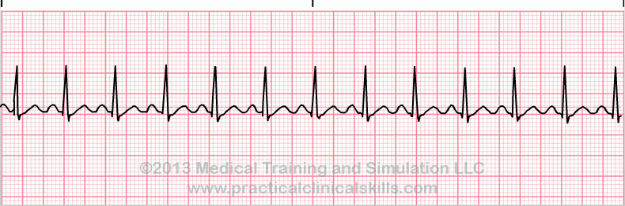

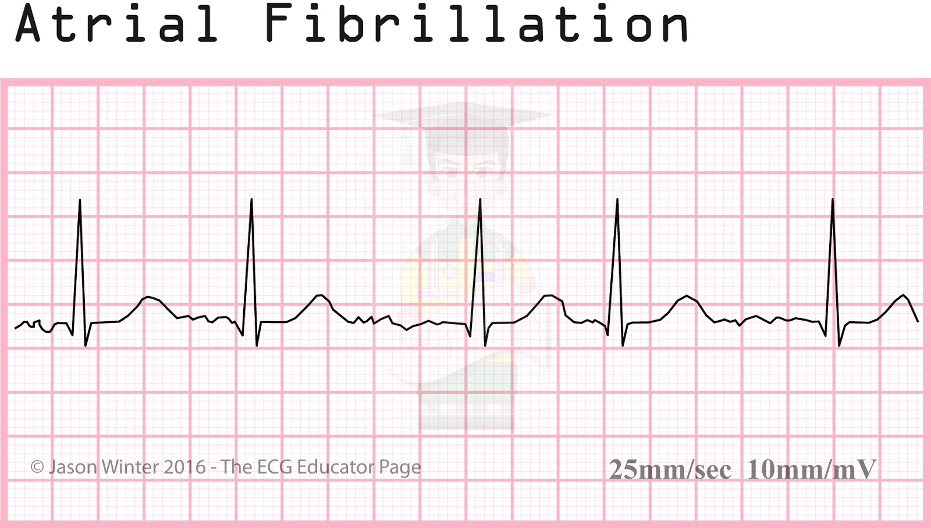

*Atrial Flutter

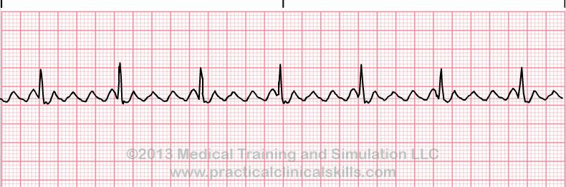

*Supraventricular Tachycardia

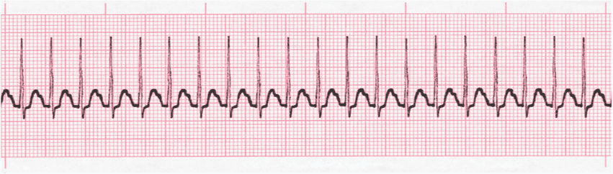

**VT

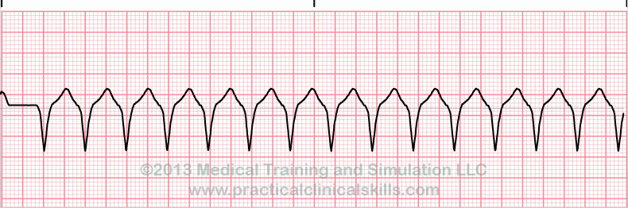

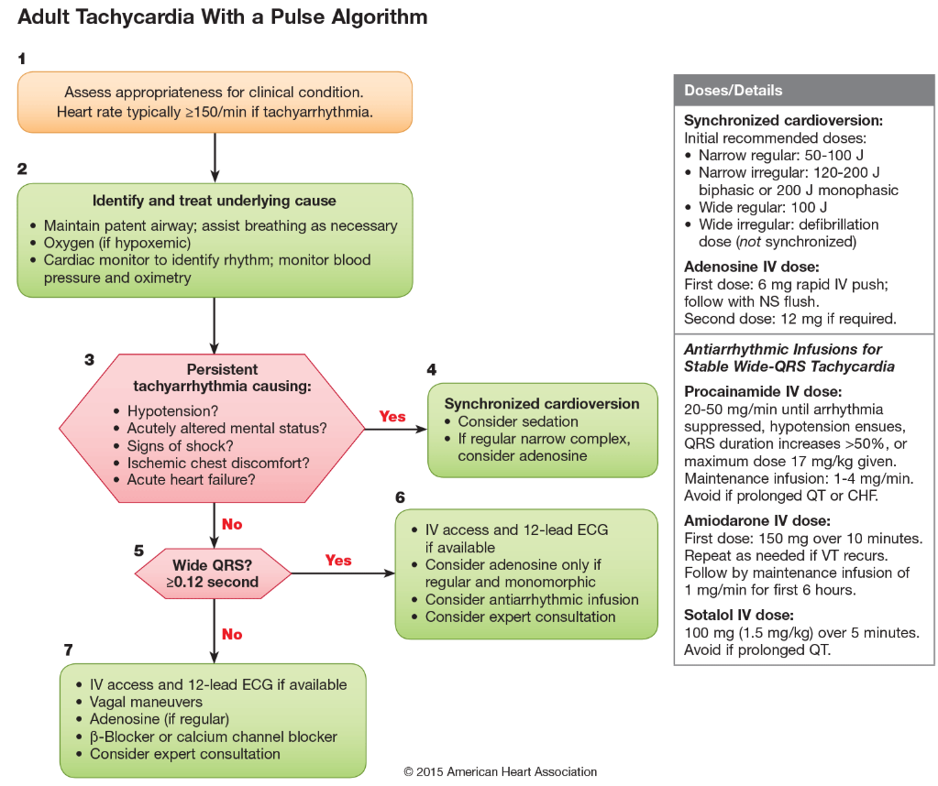*Ventricular Tachycardia

##### Bradycardia:

* Regular
  + - Sinus bradycardia
    - Junctional bradycardia
    - Complete AV block (junctional escape)
    - Atrial flutter with high degree block
* Irregular
  + - Sinus arrhythmia, pause or arrest
    - Sinoatrial exit block (second degree)
    - Atrial fibrillation with slow ventricular response
    - Atrial flutter with variable block
    - Second degree AV block, type I
    - Second degree AV block, type II
* Management
  + Get vitals first!!!

If unstable, manage per ACLS guidelines & see patient

* Go see the patient

New bradycardia? Symptomatic? dizzy, chest pain, syncope

* + Obtain EKG and compare it to old EKG
  + Questions to Consider
    - Medications: β-blockers, Calcium-channel blockers, digoxin, amiodarone, clonidine.
    - Recent blood draw, tunnel vision, & nausea? vasovagal?
    - Can be cough/micturition/emesis /defecation induced.
    - Are they having an MI?
    - Did they have a massive PE?
    - Do they have autonomic instability?
    - Do they have an infiltrating cardiac disease?
    - Do they have severe hypothyroidism?
    - Do they have increased intracranial pressure?

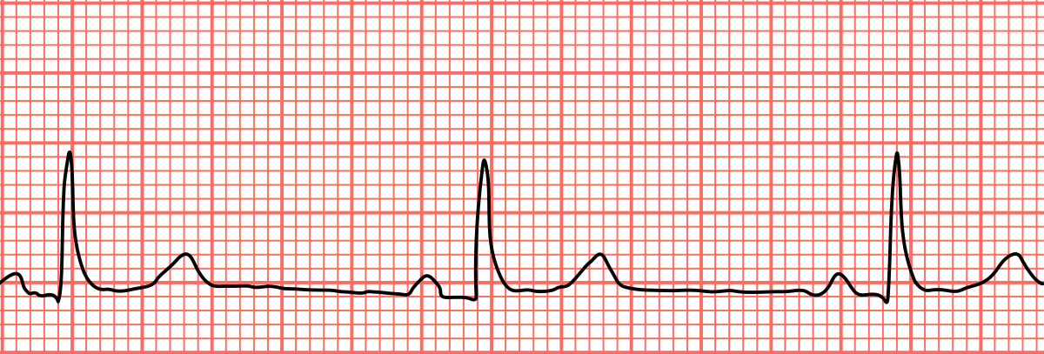

*Sinus Bradycardia

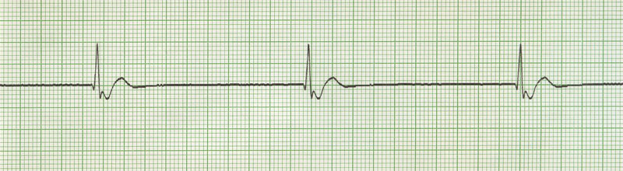

*Junctional Bradycardia

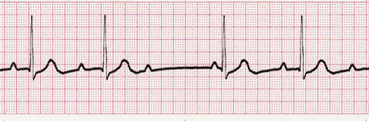

*Second Degree, Type 1 Heart Block

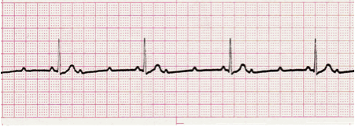

*Second Degree, Type 2 Heart Block

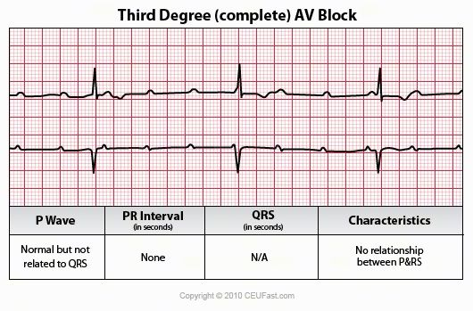

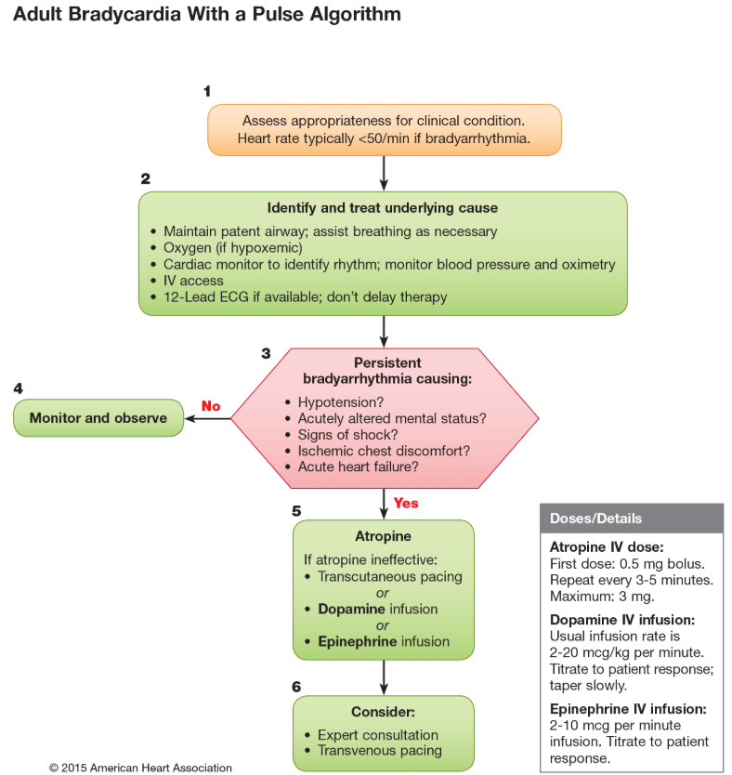

##### Nausea:

-Always consider ileus or SBO

-Chest pain and increased ICP patients can have nausea too.

-Common Rx:

* + - Reglan: 5-10mg
    - Can stimulate gastric emptying
  + Can cause a dystonic reaction if chronically used.
  + Renally dosed
  + Recall QTc prolongation
    - Phenergan: 5-10mg
  + Well tolerated
  + Has a PR form.
  + Also, can prolong QTc
    - Compazine: variable
    - Serotonin antagonists (Zofran)
  + QT prolongation
  + Serotonin syndrome
    - If patient already on serotonergic drugs (linezolid), think twice

##### Pain

Mild-Moderate Pain (1-5)

* Acetaminophen and NSAIDS (not in renal disease, GI bleeders, or ACS pts) will usually suffice.
* Don’t forget to consider topical therapies including lidocaine patch, NSAID gels

##### Moderate to Severe Pain (6-10)

* Opioids in the right clinical context. Keep in mind that Acetaminophen and NSAIDs can be just as effective or even more so. If patients were not scheduled on Tylenol you can consider doing this as well
  + 2 gram Tylenol in significant liver disease
  + 3 gram otherwise

*Morphine not to be used with significant renal impairment. You may over sedate the patient due to lack of secretion of long acting metabolite. Consider Dilaudid , but use caution. START SLOW IF YOU ARE UNSURE.

Opioid Equivalents

|  |  |  |  |  |
| --- | --- | --- | --- | --- |
| Name | Onset (min) | Dosing (qHr) | Oral Eq (mg) | I.V. Eq (mg) |
| Codeine | 10-30 | 4 | 200 | 120 |
| Hydromorphone (Dilaudid) | 15-30 | 4 | 7.5 | 1.5 |
| Levophanol (Levodromoran) | 30-90 | 4 | 4 | 2 |
| Meperidene (Demerol) | 10-45 | 4 | 300 | 75 |
| Methadone (Dolophine) | 30-60 | 6 | 20 | 10 |
| Morphine (Roxanol) | 15-60 | 4 | 30 | 10 |
| Morphine CR (MS Contin) | 15-60 | 12 | 90 | NA |
| Oxycondone (Percocet) | 15-30 | 6 | 30 | NA |
| Oxycodone CR (Oxycontin) | 15-30 | 12 | 30 | NA |
| Propoxyphene | 30-60 | 4 | 200 | NA |

##### Bowel Regimen:

Please order when you order opioids.

1. First try Senna and Docusate PO; If that doesn’t work

2. PRN Miralax, Milk of Mag, dulcolax mag citrate or Lactulose

NOTE: NOTHING FROM ABOVE IF SUSPECT Obstruction.

3. Suppository-dulcolax

4. Lastly the Enema: tap-water enema, tap water with soap suds, mineral oil, Fleet with phos (**Not to be used in CKD/dialysis patient**)

DO NOT FORGET TO R/O STOOL IMPACTION FIRST. **(no rectal exams in neutropenic pts!)**

##### Hypertension:

**A. Hypertensive Emergency:** IV meds

GOAL: Lower BP by 15-20% in 1st hour. NO MORE.

Consider: Arterial line and ICU admission.

**Recall special consideration with HTN relate dto cocaine intoxication or alcohol withdrawal🡪benzos

**Some common IV gtt (drips) that you can use**

* Esmolol
  + Great with CAD patients, tachyarrhythmias, aortic dissection
  + Rapid on/off
  + Large volume, very expensive
* Fenoldopam
  + Partial D1 agonist: good for renal dysfunction
* Hydralazine
  + Caution in acute coronary syndromes, CVAs, and dissecting aneurysm
* Labetalol
  + Alpha and non-selective beta blockade
  + Caution in patients with heart failure
* Nicardipine
  + CCB: vasodilation and decreases PVR
  + Caution in acute heart failure and coronary ischemia
* Sodium Nitroprusside
  + arterial/venous vasodilator🡪decreases preload and afterload
  + increases ICP, increases mortality if used in early AMI.
* Nitroglycerin
  + Good for pulmonary edema and acute MI

**Hypertensive urgency**

* Try short acting **oral meds** for easier titration.

- DBP usually > 130, SBP usually > 210 w/o signs of end organ damage.

-Back to normal BP in 1-2 days.

### Non Emergent Blood Pressure Elevations in the Hospital:

- Common to have HTN in the hospital

- Assess Pts Clinical scenario: **i.e. recent stroke, limb ischemia, hypertensive emergency requires slow BP normalization**

- Consider adding home meds, unless they were held for a reason?

- Can consider:

-Captopril

-IV or PO Hydralazine

-Labetalol

##### Hypotension:

* Are they Septic? Cardiogenic? Hypovolemic (bleeding/over diuresis)? Iatrogenic?
* What’s their Cardiac Ejection Fraction?
  + - 30-40% or LESS consider only 250cc to 500 v. 1L with better EF
* Patients have variable “normal” blood pressures i.e. advanced heart failure, cirrhosis, autonomic dysfunction, spinal cord injury, fit/thin patient, etc.

** Patient’s legs contain ~ 250-500cc of volume. If blood pressure and HR improve w passive leg raise, consider giving them fluid.

-If patient is NOT responsive to fluid administration, may require pressers. Don’t hesitate to call ICU when appropriate!!

**Hold medications that may cause hypotension and medications that may prevent pressor function

##### Hypoglycemia (Add hypoglycemia protocol order):

Asymptomatic?

* Able to take PO?
  + 8 oz of juice is about 30 grams of carbohydrates
  + 2 graham cracker squares = 10 g CBH
  + For every 15 g carbs, expect blood sugar rise 25-50 mg/dL
* Unable to take PO- as below

Symptomatic (tremors, diaphoresis, palpitations) or NPO patient?

* + 1 Amp of dextrose IV. Or 1mg Glucagon IM
  + Follow blood sugar closely! Q 5 min to start.
  + Consider start D5 or D10 blood sugar >100

##### Hyperglycemia:

*Don’t forget hypoglycemia is significantly more dangerous than hyperglycemia. Move slow!

*Always use extra caution with ESRD patients

*Goal between 140-180

*Can start with Insulin sliding scale but ISS alone has been shown to worsen outcomes and should not be used alone. Patient should be converted to baseline and prandial insulin when appropriate

Ex.

CBG Regular Insulin Vs. Short Acting

200-250 4 units

251-300 6 units

301-350 8 units

351-400 10 units

less than 60 or greater than 400, call your senior

**Hyperosmolar Hypoglycemic State & Diabetic Ketoacidosis**

**HHS:** Type 2 DM with illness or non-compliance with meds. Clinical presentation may range from fatigue to coma. Type 2 DM are resistant to insulin, however there is still enough insulin produced by the pancreas to prevent ketosis, therefore there is no ketone formation. The more pressing issue with HONK is hyperosmolarity which can result in hypertonic encephalopathy. These patients are markedly dehydrated and require massive fluid resuscitation.

**DKA**: Usually type 1 diabetics in scenario of infection or incorrect insulin dosing. May manifest initially as polyuria/polydipsia, dehydration and nausea/vomiting progressing to compensatory Kussmaul respirations, somnolence and eventual coma.

**Monitoring**

1) Glucose q1h

2) Electrolytes q2h (alternating BMP and VBG)

3)Neurologic status q2 hours

**Considerations**

1. DO NOT start insulin in the presence of severe hypokalemia

2. **K needs to be >3.3 **

3. ** Phos >1.5 to help prevent respiratory depression **

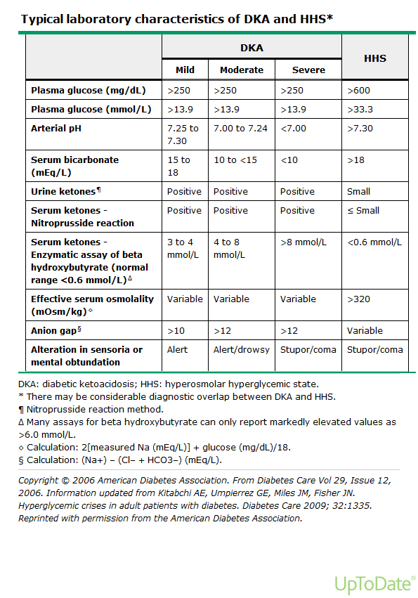**Please see the Corresponding Algorithms for HHS & DKA Below**

**When to transition to subcutaneous insulin?**

-anion gap is resolved

-bicarb is approx. >17

1. Give subcutaneous insulin (if naïve to insulin can start weight based at 0.5 units/kg, otherwise restart home dose)

2. Stop insulin drip and fluids 2 hours after long acting (glargine, NPH, detemir) subq insulin is administered

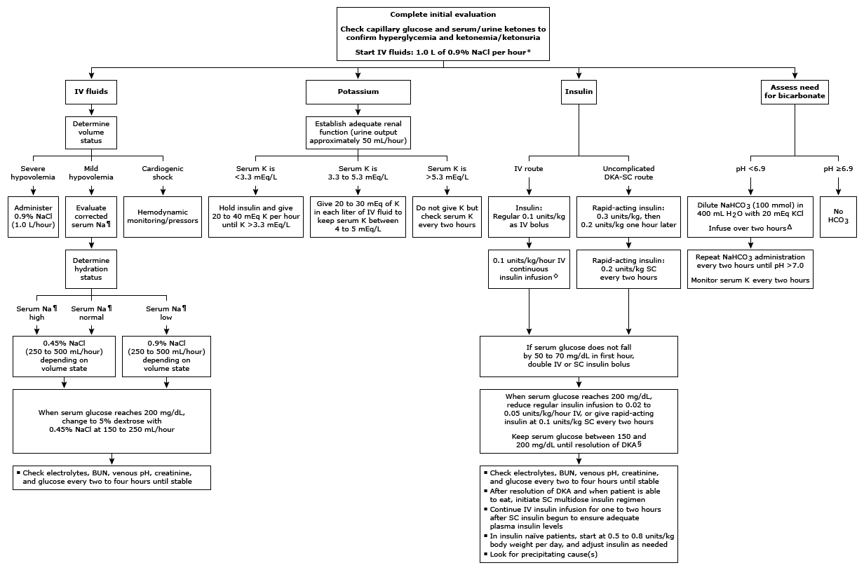

DKA Algorithm

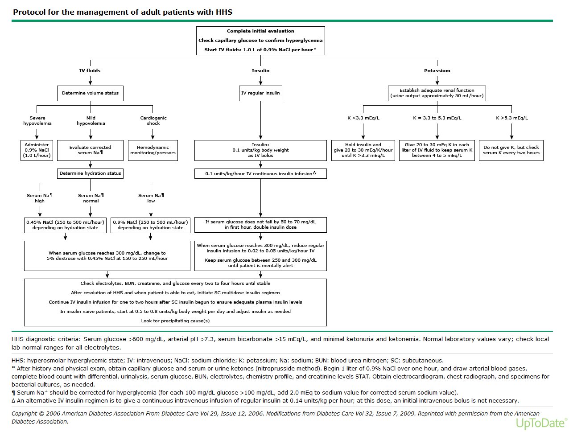

HHS Algorithm

##### Altered Mental status (Acute Encephalopathy)

DDx: hypoglycemia, CO2 narcosis, med overdose, seizure, stroke, aspiration, sepsis, ICH, delirium, Hypothyroidism, wernicke korsakoff, etc.

* First step is always evaluate patient’s hemodynamics
  + ABCDs

Oxygen with oropharyngeal airway if necessary, NO ORAL AIRWAY IF PT HAS GAG STILL

* Evaluation
  + HPI, clinical evaluation with targeted therapies
  + Evaluate recent medications given to patient
  + POCT glucose
  + CBC, CMP Mg, PO4
  + VBG/ABG
  + Blood Cxs
  + TSH
  + Drug Screen
  + Chest X-ray
  + Urinalysis
  + Brain Imaging- if focal neurologic signs or risk for CVA
  + Consider LP especially if fever/meningeal signs/immunosuppressed
* Possible Treatment
  + Consider Abx as appropriate
  + D50, 1 amp after thiamine (100mg IV)
  + Naloxone, start low and titrate up 0.4-1.2 mg IV. Give even if opioid OD seems unlikely.
  + Can even dilute naloxone into 10cc of NS in order to make it easier to titrate
  + Lift head of BED (for increased ICP) and aspiration risks.
  + BiPap
  + Thyroxine
  + Target to appropriate therapy

##### Seizures:

* Real versus Pseudo
  + Neurological examination
  + O2 by face mask/Nasal Cannula
  + position Pt. on side/semi prone to prevent aspiration. Suction PRN.

- If seizures continue after 2-3 minutes, Ativan 2 mg followed by another 2 mg if no response. Alternatively, Ativan IM Q5 minutes to max 8mg can also be done.

- some guidelines consider pheny or fospheny with Ativan if seizures do not break

* + Don’t forget to **CHECK GLUCOSE** as reversible cause

Give thiamine 100 mg IV first, then 1 amp D50 IV

* + Don’t forget to **check sodium** to ensure patient does not have severe hyponatremia

Sodium Chloride 3% given 100ml Q10min X 3

* + - Seizure >5-10 mins think status epileptics and call ICU early.

Call neuro to help determine loading med

* + - Keppra, phenytoin. Etc..

##### Chest Pain:

**DDX**

**Cardiac/Aortic**

* + ACS
  + Prinzmetals Angina
  + Drug intoxication
  + AS
  + Aortic Dissection
  + Pericarditis

**Pulmonary**

* + PE
  + Pneumonia
  + Pleuritis

**Gastrointestinal**

* + GERD
  + Diffuse esophageal spasm
  + Esophagitis/gastritis
  + Acute cholecystitis
  + Pancreatitis
  + Peptic ulcer disease

\*\*\***always consider diagnosis that can kill the patient first**: ACS, Aortic Dissection, PNA, PE, abdominal viscus rupture

** Questions to assess for “typical chest pain”

* Retrosternal?
* Improved by nitroglycerin?
* Worsened by activity?
  + 3/3= typical chest pain
  + 2/3= atypical chest pain
  + 0-1/3=noncardiac chest pain- **can still be cardiac in nature

**Management**

* + ECG STAT. Wait at the side of the bed for the EKG! Make sure to compare to old EKG

STEMI?- call senior/fellow/attending. You have 90 minutes!

* + Get troponins stat and every 6 hours or until they peak and trend down.
  + Consider obtaining chest x-ray
  + Nitro Sub Lingual q 5 min (if Blood pressure is too low can try IV morphine 2-4 mg, Start low)

May need fluids if right ventricular infarction

* + ASA full dose and have patient chew tablet.
  + Consider starting medications that reduce cardiac work

B-Blocker/CCB

Ace-I

* + Heparin gtt
  + If TIMI score is moderate or high risk consider Plavix load. Plavix load may delay CABG. Consider cardiology discussion. Rarely use G3B/2A inhibitors here but should be considered with high risk patients

##### Shortness of Breath/Respiratory Failure:

**Also see ICU Respiratory Failure for a more comprehensive overview

**DDX**

Reactive airway

PE

Fluid overload

Transfusion Rxn

PNX

ARDS

Aspiration,

etc.

Oxygen: Your goal is O2 sat > 88%

Therapies

* Start with O2 via nasal cannula (tubes in the nose), venturi mask (clear mask over nose and mouth), or non rebreather (clear mask w bag).
  + Nasal cannula:

Low Flow: 1-5 L/min: 20-40%

High Flow: up to 8L/min delivers FiO2 up to 38%

(careful in Hypercapnic patients, not recommended)

* Venturi can deliver 35-55% FiO2 @ 6-10L
* Nonrebreather can deliver 100% FiO2

****If on venturi or nonrebreather 🡪 immediately notify ICU ****

* *Beta agonists

- Albuterol continuous, Q1H, Q2H etc.

* Duo-Nebs
* Steroids: Usually for Asthma/COPD
* *Diuretics: if appropriate,

check I/Os. Can start with Lasix 40mg IV (don’t forget to adjust for renal function!). WATCH urine out put..

* + If none🡪check bladder scan, if empty🡪 double Lasix dose; If bladder full insert Foley or straight cath.

**Advanced Therapies – INVOLVE PULMONARY FELLOW!!!!**

**BiPAP can buy you time and may prevent intubation, especially in COPD exacerbation and heart failure patients. However, multiples studies have shown that BiPap for other reasons may increase mortality/morbidity by delaying appropriate intubation

**\*\*contraindications** - inability to protect airway, severe metabolic disturbance, arrhythmia, severe hypotension, upper airway trauma, facial trauma, inability to get good seal on mask, recent esophageal Sx

**\*\***GOOD INITIAL BIPAP STARTING Settings: IPAP:15 or 12 EPAP: 5 at Fio2 100%

-Decrease as tolerated based on ABG or sat >88%

**\*\*\*\*\*\*\*\*\*\*\*\*\*\*\* Critical Concepts \*\*\*\*\*\*\*\*\*\*\*\*\*\*\*\*\***

Need to get rid of CO2? Increase the IPAP and EPAP pressure difference

* (IPAP – EPAP = Tidal volume). You can increase the RR as well.
  + **Recall CO2 removal is dictated by Minute Ventilation (TvXRR)

Need to improve O2 delivery? increase EPAP (PEEP) and FIO2;

*Remember to increase IPAP equally otherwise you lose Tidal volume!!

*Try and avoid increasing IPAP >20 as the stomach may rapidly inflate and induce vomiting

*********************************************************

##### ASTHMA/COPD Exacerbation:

* Oxygen supplementation

-O2, if needed, should be tailored to achieve a pulse ox ~ 92%

-NOTE: High flow O2 use for treatment of pure asthma exacerbation is associated with increased mortality.

* Bronchodilators:

-Beta Agonists – Albuterol: No significant difference between MDI and Nebs. Can do continuous nebs if need in short term, watch for tachycardia.

* Anticholinergic – Ipratropium (DuoNeb: albuterol/ipratropium)
* Steroids – 5 day bursts ok W/O taper for asthma. However, multiples studies have shown COPD likely needs longer tapers from 8-14 days depending on severity. Remember is pt comes in on steroids they will likely need to bump him up on his dose.
* -Magnesium – 2g magnesium sulfate only has a benefit in severe exacerbations.

##### Comfort Care Medications

**There is a comfort care order set available

1. Dilaudid 0.5mg SQ q1h PRN pain
2. Oxycodone 5-10mg q3-4hrs PO PRN pain
3. Versed 2mg SQ q4h PRN anxiety
4. Lorazepam 0.5mg PO q4h PRN anxiety
5. Morphine nebs 10mg q4h PRN respiratory distress (may mix with albuterol/atrovent)
6. Morphine 1-2mg q2h SQ PRN respiratory distress
7. For respiratory rattling
   1. Atropine 1mg SQ q4hr PRN

Glycopyrrolate 0.6mg nebs q4hrs PRN

##### Electrolytes

Below are suggestions for electrolyte replacement but each clinical scenario may differ. When in doubt, please check with your senior.

##### Potassium:

##### Hypokalemia: K <3.5mEq/L

|  |  |  |
| --- | --- | --- |
| Causes | Complications | Therapy |
| -inadequate intake  -vomiting/NG drainage  -diarrhea  -diuretics  -hypomagnesemia  -Cushing’s syndrome  -Alkalosis  -Insulin  -Beta-adrenergic agents | -muscle weakness  -cramps  -tetany  -polyuria/polydipsia  -orthostatic hypotension  EKG: flattening of T waves, U wave development | **IV**: 10mEq/hr for peripheral IV K+, <20-24mEq/hr through central line. Max of 40meq/hour  **Oral** KCl 20-40 mEq BID-TID  -Treat hypomagnesemia  **caution with patient’s with increased Cr |

|  |  |
| --- | --- |
| **Serum K** | **mEq KCl to give PO/IV (Goal of 4.0)** |
| 3.7 to 3.8 | 20 |
| 3.5 to 3.6 | 40 |
| 3.3 to 3.4 | 60 |
| 3.1 to 3.2 | 80 |
| < 3.0 | 100 |
| 10mEq of KCl will raise K levels by 0.1 | |

\*\***Important considerations**

-10mEq of KCL will not raise K levels by 0.1 if the potassium is severely depleted. You may end up giving 10-40mEq of KCL to raise it by 0.1

-please be careful giving patient’s with CKD/ESRD potassium IV as they will not be able to autocorrect. Oral KCL can be substituted and works well with better auto correction.

##### Hyperkalemia: K >5.2mEq/L

|  |  |  |
| --- | --- | --- |
| Causes | Complications | Therapy |
| -Inadequate renal excretion of potassium  -Acidosis  -Renal Failure  -volume depletion  -Hypoaldosteronism  -Hemolysis  -Drugs which block RAAS: ACEi, K sparing diuretics, NSAIDs, heparin, TMX/SMP, pentamide  -Massive Transfusions | -Weakness  -Flaccid paralysis  -Confusion  -Hyperactive DTRs  EKG: peaked T waves (usually in V2 and V3), widened QRS, loss of P wave, asystole  -Vfib (K >8) | Review meds → stop any iatrogenic causes  -Calcium gluconate or chloride – give IV over 3 minutes. This will help to stabilize cardiac membrane, give when EKG changes  **SHIFT**  -10 units regular insulin IV with 1 amp of D50  -sodium bicarb  **EXCRETE**  -kayexalate 20-60g orally  -diuretics (Lasix)  -dialysis |

##### Magnesium :

|  |  |
| --- | --- |
| **Serum Mg** | **gm of MgSO4 to give IV (goal of 2.0)** |
| 1.8 to 1.9 | 1g |
| 1.6 to 1.7 | 2g |
| 1.4 to 1.5 | 3 |
| 1.2 to 1.3 | 4 |
| < 1.2 | 5 |
| Give each gram over one hour | |

Options for oral replacement

|  |  |  |
| --- | --- | --- |
| **Drug** | **Dose per tablet** | **Typical dose** |
| Mg Oxide | 420 mg | 1 to 2 tab qd |
| Mg gluconate | 500 mg | 1 to 2 tab qd |

Calcium**:**

**Hypocalcemia: Ca <8.4**

Corrected Calcium = [0.8 x (4.0 – serum albumin)] + serum Ca

|  |  |
| --- | --- |
| Causes | Complications |
| -Hypoalbuminemia  -Sepsis  -PTH deficiency  -Vitamin D deficiency  -Hyperphosphatemia  -Pancreatitis  -Osteoblastic metastases  -Massive transfusion  -Hypomagnesemia | -Hypertension  -Peripheral and perioral paresthesia  -Abdominal pain  -Lethargy  -Hyperreflexia  -Trousseau’s sign  -Positive Chvostek’s sign  -Seizures/tetany  - EKG: prolonged QT interval |

|  |  |  |
| --- | --- | --- |
| **Serum Ca mg/dl** | **Replacement** | **Notes** |
| Symptomatic - or -  Asymptomatic <7.5 | IV Ca-Gluconate 1-2 g +/- infusion | Gluconate preferred due to reduced risk of tissue necrosis |
| 7.5-8.0 | 1500-200mg Ca-carbonate or citrate in divided doses |  |

**Hypercalcemia: Ca >10.2**

|  |  |  |
| --- | --- | --- |
| Causes | Complications | Therapy |
| -Hyperparathyroidism  -Malignancy  -Sarcoidosis  -Renal failure  -Thiazide diuretics  -Milk-alkali syndrome  -Exogenous intake | -stones, bones, moans, groans = renal colic, osteitis fibrosa, constipation, confusion -polyuria/polydipsia  -fatigue  -anorexia  -nausea/vomiting  -hypertension  -hyporeflexia  -mental status changes EKG: shortened QT interval | -Saline diuresis: D5NS @ 250- 500ml/H  -Lasix 40mg IV q2h to a goal UO of 100-200mL/minute (this volume must be replaced with NS)  -Chronic: calcitonin, corticosteroids, pamidronate, plicamycin, dialysis |

##### SODIUM

##### Hyponatremia: Na <135mEq/L

**Symptoms:** Lethargy, Confusion/coma, mental status changes Muscle twitches/seizures Nausea/vomiting, Hyperreflexia ARDS

|  |  |  |  |
| --- | --- | --- | --- |
| **Hypoosmolar**  **Hyponatremia** | **Hypervolemic** | **Euvolemic** | **Hypovolemic** |
| Causes: | -CHF  -Nephrosis  -Renal Failure  -Cirrhosis/Liver dz | -SIADH  -hypothyroidism  -psychogenic polydipsia  -adrenal insufficiency | -renal loss/diuretics  -vomiting/diarrhea  -third spacing  -Addison’s disease |
| TBW  TBNa | ↑↑  ↑↑ | ↑  -- | ↓↓  ↓ |
| PE  Lab | Peripheral Edema  UOsm High  UNa High | Lethargy, seizure  Renal: UOs Low  Non: Uosm High | Orthostatic, hypoTN  Renal: UOs High, UNa high  Non: UOsm High, UNa low |
| Treatment: | Water restriction, Diuretics/Dialysis | -H20 restriction -treat underlying cause  -refractory +/- demeclocycline | -replace with NS |

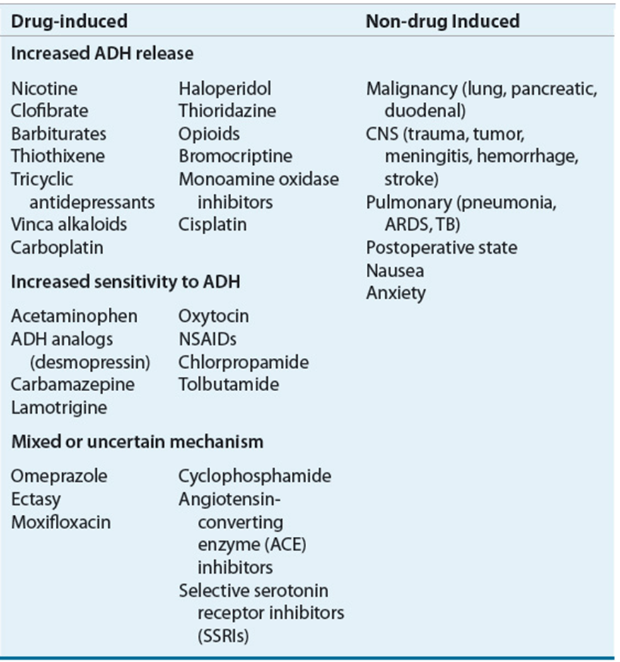

**EVALUATION**

**STEP 1:** If hyperglycemia**, Corrected Na = [Na]serum + [1.6 x [glucose -100)/100]].** If sodium is normal, hyperglycemia induced

**STEP 2:** Hyperosmolar v. iso-osmolar v. hypoosmolar

**a.** lipemic or plasma cell dyscrasia?

**i.** Direct potentiometry sodium OR measure total protein and/or lipids🡪 elevated 🡪 pseudohyponatremia

**b. Low (hypo-osmolar). Proceed to step 3**

**STEP 3: Volume Status**

**a. Hypervolemic: due to low effective arterial blood volume**

**i. Heart failure v. Cirrhosis v. Nephrosis**

**b. Euvolemic/Hypovolemic:** Measure Urine Osm and Urine Na

a. UNa <40 OR UOsm <100 = Hypovol. HypoNa

b. U Na >40 and U Osm >100 = Euvol HypoNa

**c. Measure TSH and AM cortisol**

**To calculate replacement NaCl:**

STEP 1: Calculate Na deficit

Sodium deficit (mEq) = normal TBW x (130 – Serum Na)

STEP 2: Calculate the infusion time

Infusion time (hours) = $\frac{Sodium deficit \left(mEq/L\right)}{0.5meq/L/hr=safe rate of correction}$

STEP 3: Calculate the volume of 3% Na Cl necessary to replace deficit

Volume 3% NaCl (mL) = $\frac{Sodium deficit \left(mEq/L\right)}{\frac{513meq}{L}=amt of Na in 1L 3\%}$

Can be done with 0.9% NaCl, ½ NS

STEP 4: Calculate the infusion rate

Infusion Rate (mL/hr) = $\frac{Volume 3\% NS \left(ml\right)=Ans Step 3}{Infusion Time \left(hr\right)=Ans Step 2}$

**SYMPTOMATIC HYPONATREMIA**

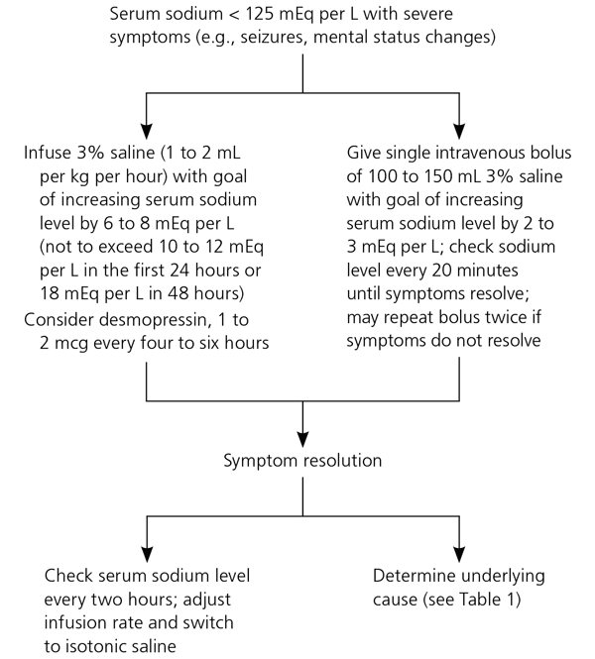*Initiate 3% NaCl (hypertonic saline) to quickly correct Na if seizing or coma

** optimal rate of correction is 4-6mEq/L in 1st 24hrs. Na should not be corrected >10 mEq/L in 1st 24hrs or more than 18mEq/L in 48hrs as this places patients at risk to develop central pontine demyelinosis.

##### 

##### Hypernatremia, Na > 145mEq/L

Free water deficit (L) = $\frac{0.6 x Wt \left(kg\right)x \left(Serum Na – 140\right)}{140}$

|  |  |  |
| --- | --- | --- |
| **Causes** | **Complications** | **Therapy** |
| -osmotic diuresis  -diabetes insipidus  -Cushing’s syndrome  -hyperaldosteronism | -confusion  -lethargy  -stupor  -seizures/coma /altered mentation | Hypovolemic: Rehydrate w/ NS:  Euvolemic:  -Calculate and replace water deficit: administer as D5W or ½ NS  -Give ½ volume in 1st 24 hrs and remaining in the following.  Hypervolemic: Lasix +/- D5W |

**Phosphorous**

**Hypophosphatemia <2.5 mg/dL**

|  |  |  |
| --- | --- | --- |
| Causes | Complications | Therapy |
| -intestinal malabsorption  -chronic diarrhea  -vitamin D deficiency  -starvation/anorexia  -alcoholism  -Fanconi’s syndrome  -severe burns  -post feeding syndrome  -respiratory alkalosis | -muscle weakness  -hemolysis  -rarely develop neuro disorders | Acute: replace with IV  -Kphos: 3mmol/ml of phos; 4.4 mEq/ml of K  -Na phos: 3mmol/ml of phos; 4.0 mEq/ml of Na  Preferable method: replace PO  -milk  -Neutraphos K capsules: 250mg/ capsule with max dose of 3 tabs q6h  -Neutraphos solution: 128mg/mL |

|  |  |  |
| --- | --- | --- |
| **Serum Phos** | **IV K-Phos or Na-Phos** | **Oral** |
| 2.0 to 2.5 | 15 mmol | 1 mmol/kg/day in divided doses |
| 1.0 to 2.0 | 21 mmol | 1.3 mmol/kg/day in divided doses |

*IV: 15 mmol K-Pho = 22 mEq K+ & 15 mmol Na-Phos = 22 mEq Na+

2**.Hyperphosphatemia >4.5 mg/dL**

|  |  |  |
| --- | --- | --- |
| Causes | Complications | Therapy |
| -increased intestinal absorption  -ESRD due to decreased renal excretion  -Tumor lysis syndrome  -hemolysis, rhabdomyolysis  -hyperthermia | Usually asymptomatic.  -symptoms mostly occur from concomitant hypocalcemia | -volume expansion (fluids)  -dialysis  -oral phosphate binders (calcium carbonate, calcium acetate or sevelamer carbonate) |

##### INTRAVENOUS FLUIDS

**Crystalloids:** does not remain in the intravascular space, resuscitative volumes will cause interstitial hypervolemia that resolves over 3-4 days.

|  |  |  |  |  |  |  |  |
| --- | --- | --- | --- | --- | --- | --- | --- |
| **Fluid** | **Glucose** | **Na** | **Cl** | **K** | **Ca** | **Mg** | **Osmolality**  **(mOs/L)** |
| Plasma | 80-100 | 141 | 103 | 4-5 | 5 | 2 | 289 |
| 3% NS |  | 513 | 513 |  |  |  | 1026 |
| NS |  | 154 | 154 |  |  |  | 308 |
| ½ NS |  | 77 | 77 |  |  |  | 154 |
| Normosol |  | 140 | 98 | 5 |  |  | 295 |
| LR |  | 130 | 109 | 4 | 3 |  | 273 |
| D5W | 50 |  |  |  |  |  | 278 |
| D10W | 100 |  |  |  |  |  | 556 |

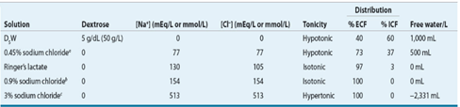

**Colloids**

Colloids replace plasma volume. The most commonly used colloid is 5% albumin derived from human plasma. Its oncotic pressure and activity is similar to that of plasma. About half of the infused amount remains intravascular with the effect lasting 12 – 18 hours. Albumin is also available in a 25% preparation used for rapid volume expansion in hypoproteinimic individuals by drawing the interstitial fluid into the vascular space. Other colloids such as have not been shown to be beneficial in Sepsis

|  |  |  |  |
| --- | --- | --- | --- |
| **Colloid** | **Concentration** | **Colloid osmotic pressure** | **Duration of effects** |
| 5% albumin | 50g/L | 20mmHg | 12-18 hours |
| 25% albumin | 250g/L | 70mmHg | 12-18 hours |

##### Infectious Disease

Antibiogram:

This can be found on the Banner intranet by going to: Docs & Residents tab 🡪Physicians portal 🡪Antibiograms

Approach to Fever in the ICU:

-Fever is defined as a temp >100.4◦F

- Investigation for source should be done:

“Pan-culture” frequently finds colonization. Therefore consider:

-Two sets of blood cultures from 2 different sites

-Chest radiograph

-Sputum for gram stain and culture

-Examine line sites for signs of infection. If there is erythema and existing access permits, remove the catheter

-Start antipyretic therapy

-If the patient is immunocompromised or has signs of sepsis, start empiric therapy to cover gram negatives and any suspected gram-positive organisms

Do not repeat cultures on a schedule or if recently obtained.

Common causes of nosocomial fever:

-sinusitis

-pancreatitis

-catheter sepsis (urinary, central lines)

-translocation

-drug fever

-enterocolitis

-wound infection

-bowel infarction

-pneumonia

-urosepsis

-pulmonary embolism

-DVT

-MI

-acalculous cholecystitis

-endocarditis

-perforated ulcer

Line Infections

- Occur by seeding of the catheter tip by local flora at the insertion site or sterile technique failure during maintenance.

- Most common organisms: Staph epidermidis, then Staph aureus & GNRs.

- May present as fever of unknown origin with or without evidence of local infections (i.e. erythema).

- If a line infection is suspected, catheter should be removed. Vascular access may be limited requiring continuation of line. If so, start empiric therapy, and obtain a culture from the suspected catheter and another from a distant site.

- If the colony count of suspected line culture = at least 3x distant site culture or line culture positive 2 hours before peripheral a line infection is presumed.

-Typically, peripheral IV lines should be changed every 3 days. An arterial line should be changed or removed if line infection is suspected.

**Antibiotics**

1.Vancomycin (IV)- always consult pharmacy for dosing: bacteriostatic

All GRAM POSITIVES – except VRE

* Staphylococcus, vancomycin sensitive enterococcus
* Strepotococcus (including S pneumo)
* Gram positive rods (C Diff – only time PO vanc is used)
* NO GRAM NEGATIVE coverage

Need to monitor trough levels, drawn 30 minutes in 48 hours of initiation, typically prior to the 4th dose.

* Goal is usually 15 – 20 (especially for pneumonia, bacteremia)
* If continuous infusion, goal is 20 – 30 Adverse effects:
* Red Man Syndrome: not a true allergic reaction. Give Benadryl, H2 blocker and slow down rate of infusion
* Nephrotoxicity: need to monitor trough levels to prevent this. Usually occurs when used with other nephrotoxic agents

2.Telavancin – approved for cellulitis in 2009, and recently improved for HAP/VAP in 2013

* More bactericidal than vanc
* More nephrotoxic than vanc, teratogenic, may prolong QT, interferes with INR testing
* No bacteremia trials.
* Would only use as salvage therapy with the recommendation by ID

3.Penicillins

A. Penicillin G (IV) or Penicillin VK (PO)

* Reliably kills Streptococci (except S pneumo)
* Neisseria meningitides, syphilis
* Cheap and very bactericidal

B. Oxacillin/Nafcillin (IV), Dicloxacillin (PO)

* Ox/Naf achieve a higher serum concentration than PO form
* Narrow spectrum – destroys staph and strep
  + Misses MRSA, gram negatives
* Most bactericidal agent against susceptible MSSA
* Drug of choice (DOC): Endocarditis, Ostemomyelitis if MSSA has been cultured

C. Ampicillin IV, Amoxicillin PO

* Susceptible to beta-lactamase
* Broader spectrum than PCN G and Oxacillin
* Covers certain gram negatives
* Misses: staph 95% of the time (If resistant to PCN than can’t use Amp or Amox)
* Use: otitis media, bronchitis, sinusitis, UTI
* DOC: Enterococcus (if sensitive)

D. Augmentin (PO) and Unasyn (IV)

* Broader spectrum due to beta lactamase inhibitor
* Covers many gram + and gram – and anaerobes
* Misses: MRSA, pseudomonas, atypical

E. Zosyn (piperacillin-tazobactam) IV only

* Broad Coverage
* Covers: Gram +, gram – (including pseudomonas), anaerobes Enterococcus (if sensitive to ampicillin)
* Misses: MRSA, VRE, atypical

Gram negatives with an extended spectrum beta-lactamase (ESBL)

4. Carbapenem (IV Only) – some cross reaction in PCN allergies, avoid if possible

A. Meropenem/Imipenem

* Almost same coverage as Zosyn, but less resistance (can use for ESBL)
* Tends to promote resistant organisms. Don’t use unless absolutely needed
* Imipenem can cause seizures

B. Ertapenem

* Not as broad.
* Misses: pseudomonas, enterococcus, Acinetobacter
* Advantage: once a day

5.Aztreonam (IV Only)

* Expensive
* Ok to use in PCN allergic patients (this is its only use really)
* Covers: only gram negatives, including pseudomonas

6.Cephalosporins

-A. 1st generation

* Cefazolin (Ancef) and Cephalexin (Keflex)
* Similar to nafcillin
* Ancef – primary surgical prophylaxis

B. 2nd generation

* Cefuroxime, Cefaclor: similar to Amoxicillin
* Cefotetan, Cefoxitin – also kills anaerobes, give for surgical ppx prior to abdominal surgeries

C. 3rd generation

1. Cefotaxime, Ceftriaxone

* Covers: Gram + (S pneumo), more gram negative coverage
* Misses: MRSA, enterococcus, pseudomonas, anaerobes or atypicals
* Penetration: these both cross the blood brain barrier
* USE: community acquired pna (in combination with azithro), meningitis, pyelonephritis

1. Ceftazidime: kills pseudomonas. Usually use Cefepime due to high resistance

D. 4th generation

Cefepime (IV)

* Very broad spectrum; Good for gram -, gram + and pseudomonas
* Misses: anaerobes, atypicals and enteroccous
* Used to treat neutropenic fever, gram neg infections, pseudomonas

E. 5th generation

Ceftaroline (IV): Only beta lactam that covers MRSA

* Approved for cellulitis and CAP

7.Fluoroquinolones (PO and IV)

* Always try to use PO – near 100% bioavailability
* Not good for staph aureus – usually don’t use for staph aureus bacteremia, even if the organism is susceptible

Moxifloxacin

* Excellent for S pneumo, most gram – and atypicals. Decent gram +
* Misses: pseudomonas, MRSA
* Does not penetrate urine well – do not use for UTI or pyelo

Levofloxacin

* Similar to moxi, except this covers pseudomonas at 750mg Qd dosage

Ciprofloxacin

* Not as good for S pneumo,
* Best fluoroquinolone for pseudomonas, gram neg and urine infections

8.Macrolides: **be careful with drug interactions**

Azithromycin (PO and IV)

* Very long half life – therapeutic for appro 7 days after stopped
* Covers: strep pneumo, atypicals, some gram –ve
* Used to treat bronchitis, otitis media, pneumonia

Clarithromycin (PO and IV)

* Similar to azithro but dosage is BID

9.Clindamycin

* Covers: anaerobes, staph strep
* Misses: Gram negative coverage
* Used to treat aspiration pneumonia, anaerobic infections
* Increasing resistance (esp to strep)
* May decrease toxin production in severe strep/staph (i.e cellulitis)
  + Will use higher dose for toxic shock syndromes and necrotizing fasciitis

10.Aminoglycosides (IV only)

Gentamicin, Tobramycin, Amikacin

* Cover: Gram negative (including pseudomonas)
* Has synergy with PCN against staph and enterococcus
* Misses: gram + and anaerobes
* Mostly used in CF patients
* Watch for ototoxicity and nephrotoxicity

11.Bactrim (PO and IV)

* Covers: some gram + and some gram –, good for MRSA
* Misses: pseudomonas, anaerobes, group A strep
* Uses: simple UTIs, bronchitis, PCP
* Bacteriostatic – don’t for bacteremia or endocarditis
* Not great as single agent for cellulitis if used for cellulitis: use 2 DS tabs BID and add strep coverage
* Side effects: rash, drug rxn, bone marrow suppression, nephrotoxic, hyperkalemia

12.Tetracyclines: Do not use with pregnancy

Doxycycline (PO and IV) and Minocycline

* Cheap
* Covers: Very good gram +, MRSA, atypicals, some enterococcus, and kills rickettsia, borrelia, coxiella, etc
* Bacteriostatic: not good for MRSA bacteremia

13. Metronidazole (Flagyl) PO and IV

* 100% bioavailability
* Covers: Outstanding anaerobic coverage, good tissue penetration; Kills giardia, Entamoeba, trichomonas
* Misses: gram + & gram – coverage

14.Daptomycin (IV Only)

* Covers: resistant gram + organisms (MRSA, VRE)
* Bactericidal
* Very Expensive
* Not a good antibiotic for pneumonia because deactivated by surfactant
* Rhabdomyolysis is a side effect, must **monitor CK weekly** and DC statins

15.Linezolind (PO and IV)

* Covers: all gram + organisms
* 100% bioavailable
* Bacteriostatic – not recommended for endocarditis
* Expensive
* Causes pancytopenia (esp. thrombocytopenia), optic neuritis, neuropathy
* Can also cause Serotonin Syndrome, caution with other meds

16.Colistin (IV only)

* Only use again pseudomonas that are resistant to everything
* Normally used in CF patients
* Causes acute renal failure

**Pneumonia - Lung infection caused by bacteria, virus or fungi**

CAP (community acquired pneumonia): non-hospitalized patient w/o extensive healthcare contact

Most common pathogens: S pneumonia, Haemophilus influenza, Moraxella catarrhalis, Mycoplasma pneumonia, Chlamydia pneumonia and Legionella sp.

- viral infection or influenza (during heightened season)

-Must think of cocci as well

-Treatment:

-Levofloxacin or moxifloxacin

-Ceftriaxone + azithromycin

-Unasyn + azithromycin

-tamiflu (if concern for influenza)

-fluconazole (if concern for cocci)

HAP (hospital acquired pneumonia): develops > 48 hours after hospitalization

VAP (ventilator-associated pneumonia): >48 to 72 hrs post endotracheal intubation

With HCAP, HAP and VAP, concern for infection with MDRO, MRSA and pseudomonas. Therefore, therapy should be aimed to target these pathogens.

Treatment:

-MRSA: Vancomycin or Linezolid

-anti-pseudomonal: Zosyn, Cefepime or Cipro

**if Cefepime is the drug of choice and there is concern for aspiration, Flagyl should be added**

##### Screen Clipping

##### Sepsis

Life-threatening condition that arises when the body’s response to an infection injures its own tissues and organs. Sepsis mortality can be up to 40%. Rapid identification and therapy initiation is extremely important.

We have always defined sepsis by first using the SIRS criteria and expanding on that based on the severity.

SIRS Criteria: must meet 2 or more of the following to meet SIRS criteria

a. Temperature >38C or <36C

b. HR >90bpm

c. RR >20 breaths/min or pCO2 <32

d. WBC >12,000/mm3 or <4000/mm3 or >10% bands Sepsis: SIRS + suspected infection

Severe sepsis: Sepsis + organ dysfunction, hypoperfusion or hypotension, lactate >4mmol/L; SBP <90 mmHg after IVF

Septic Shock: persistent hypotension requiring the need for vasopressors to keep MAP >65

In February 2016, new guidelines were published to define sepsis.

Singer, M et al. The third international consensus definitions for sepsis and septic shock (Sepsis-3). JAMA 2016; 315(8): 801-810

The conclusion is that patients with suspected infection likely to have a prolonged hospital stay can be identified at the bedside using qSOFA

qSOFA (quick SOFA) criteria

RR >22/min

Altered mentation

SBP <100 mmHg

The following is a flow chart for diagnosing sepsis/septic shock:

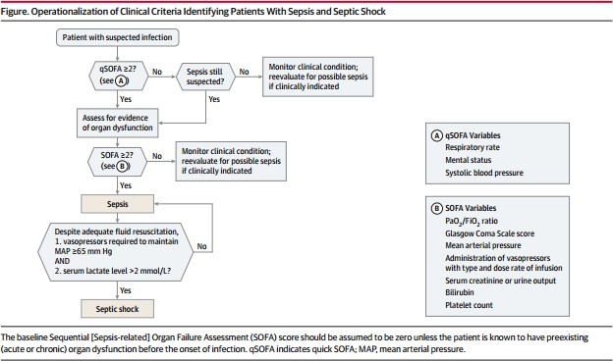

Treatment for Sepsis:

(*) **Treatment for Sepsis is time sensitive. Fluid administration, cultures, initiation of antibiotics and lactate checks are monitored by the CMS. Mortality increases by about 6% for every hour of antibiotics delayed.**

- Fluid resuscitation: 30cc/kg in form of NS or LR

**goal is to reduce the lactate 20-50%

- Pan-culture: blood culture x 2 separate sites, urinalysis, sputum culture (if producing sputum)

- start broad spectrum antibiotics

- hypotensive despite adequate fluid challenge (as per above) 🡪central line and start vasopressors to maintain MAP >65

- ScVO2 from central line

-if ScVO2 is <70 consider inotrope if depressed EF on bedside echo or transfuse RBC if indicated

- Lactate q2-4 hours until normalizes

During all the above, every attempt should be made to control source of infection. This should be done by

1. Antibiotics

2. if abscess 🡪 needs drainage either by surgery or IR

3. if nec fasc, wound, etc 🡪 eval for surgical debridement

Adequate Fluid Resuscitation can be reassessed by the following:

1. passive leg raise test:

2. bedside ultrasound

3. pulse pressure variation (PPV) per aline tracing

4. CVP (central venous pressure) – not routinely used

It is important to document as such:

**Reassessment after Initial Fluid Resuscitation:**

Date/Time:

Vital Signs:

Cardiovascular: (regular, irregular, NSR, tachycardia, bradycardia, JVD)

Pulmonary: work of breathing (improved, worsen, unchanged)

Capillary Refill: *** seconds

Skin: (normal, pale, diaphoretic, mottled, cool, warm, ***)

Pulse: (normal, bounding, thready, ***)

Reassessment after Initial Fluid Resuscitation:

Date/Time:

-CVP (N/A, *** mmH2O)

-ScvO2 (N/A, ***%)

-Bedside cardiovascular ultrasound (N/A, < 50% IVC respiratory variation, > 50% IVC respiratory variation,***)

-Dynamic assessment of fluid responsiveness with passive leg raise or fluid challenge (fluid responsive, not fluid responsive)

##### Hemodynamic Parameters

|  |  |  |
| --- | --- | --- |
| Parameter | Equation | Normal Range |
| Mean Arterial Pressure (MAP) | SBP + (2 x DBP)/3 | 70-105 mmHg |
| Systolic Pressure Variation (SPV) | (SPmax-Spmin) | <5mmHg – unlikely to be preload responsive  >5mmHg – likely preload responsive |
| Stroke Volume Variation (SVV) | (Svmax-Svmin)/[(Svmax + Svmin)/2] x 100 | <10% - unlikely to be preload responsive  >13-15% - likely to be preload responsive |
| Cardiac Output (CO) | HR x SV/1000 | 4-8 L/min |
| Cardiac Index (CI) | CO/BSA | 2.5-4 L/min/m2 |
| Stroke Volume (SV) | CO/HR x 1000 | 60-100 mL/beat |
| Stroke Volume Index (SVI) | CI/HR x 100 | 33-47 mL/m2/beat |
| Systemic Vascular Resistance  (SVR) | 80 x (MAP – RAP)/CO | 800-1200 dynes * sec/cm5 |
| Systemic Vascular Resistance  Index (SVRI) | 80 x (MAP – RAP)/CI | 1970-2390 dynes *  sec/cm5/m2 |
| Mixed Venous Saturation (SvO2) |  | 60-80% |

##### VASOACTIVE AGENTS

|  |  |  |  |  |  |
| --- | --- | --- | --- | --- | --- |
|  | β-1 (heart) | β-2 ((lungs, mast cells, vessels) | α-1 (vessels) | DA | V1 |
| Phys. Effect | Tachycardia Inotropy | Venous + arterial dilatation | Venous + arterial constriction | Renal/ mesenteric/ coronary artery dilatation | Vascular smooth muscle vasoconstriction |
| Hemo. Effect | ↑CO, HR | ↓SVR | ↑SVR, MAP | ↑UOP | ↑UOP, SVR, MAP |

|  |  |  |  |  |  |  |
| --- | --- | --- | --- | --- | --- | --- |
| Vasopressor | β-1 | β-2 | α-1 | DA | Usual Dose | Max Dose |
| Dopamine | ++++  5-10  mcg/kg/min | +  5-10  mcg/kg/min | +++  10-20  mcg/kg/min | ++++  0.5-3  mcg/kg/min | 2.5-10  mcg/kg/min | 20  mcg/kg/min |
| Norepi (Levophed) | ++ | 0 | ++++ | 0 | 1-30  mcg/min | 150  mcg/min |
| Dobutamine | ++++ | + | + | 0 | 2.5-5  mcg/kg/min | 40  mcg/kg/min |
| Epinephrine | ++++ | +++ | ++++ | 0 | 1-20  mcg/min | 30 mcg/min (but actually there is no real max dose) |
| Phenyleph. | 0 | 0 | ++++ | 0 | 100-180  mcg/min | 300  mcg/min |
| Vasopressin (works on V1) | 0 | 0 | 0 | 0 | 0.03 units/min | 0.04 units/min |

|  |  |  |  |
| --- | --- | --- | --- |
| **Vasopressor** | **Clinical Uses** | **Adverse Effects** | **Clinical Pearls** |
| Norepinephrine (Levophed) | First line for hypotension in septic shock | Peripheral hypoperfusion and tissue necrosis Reflex tachycardia Worsening cardiac ischemia Ventricular arrhythmias | May compromise coronary blood flow in setting of increased myocardial oxygen demand Can cause tachycardia or worsen afib with RVR, in this case would consider changing to phenylephrine if no contraindications |
| Dopamine | Can be used in cardiogenic shock (heart failure specialist love this med) | Tachycardia  Ventricular arrhythmias Pulmonary edema Angina | Renally dosed dopamine (<3 mcg/kg/min) no more effective at increasing renal perfusion  May worsen pulmonary congestion in those with increased preload  Needs a central line for administration |
| Vasopressin | Refractory hypotension in septic shock (second line agent after Levo)  Hypotensive with GIB (causes mesenteric vasoconstriction)  Management of hypotension after CABG | Renal, coronary, and mesenteric ischemia  Arrhythmias Bradycardia Hyponatremia Hypertension | Avoid use in acute cardiogenic or hemorrhagic shock (decreases CO and UOP)  Dose for septic shock is fix and should not be titrated (0.03) |
| Dobutamine | Useful in cardiogenic shock | Increased risk of arrhythmia, especially in pts with afib  Hyper or Hypotension Tachycardia  Angina | Not useful in ischemic heart disease because it increases heart rate and therefore myocardial oxygen demand |
| Epinephrine | 2nd line treatment for septic shock  Anaphylactoid reactions Cardiac arrest  Status asthmaticus | Elevated serum lactate Reflex bradycardia Tachyarrhythmias  Pulmonary vasoconstriction  Palpitations | Impairs glucose metabolism → elevated serum lactate  Gut ischemia |
| Phenylephrine (Neosynephrine) | Hypotension in shock syndromes in pts with significant tachycardia and avoidance of increased myocardial oxygen demand | Ventricular arrhythmias Reflex bradycardia Paresthesia Hypertension | Longest half life – may cause hypertension with aggressive up-titration  Decreases venous return |

##### CARDIOLOGY

##### Shock:

Evidence of impaired multisystem organ perfusion Clinical symptoms:

a. altered mental status

b. decreased UOP

c. diaphoresis, cold skin

d. tachypnea

e. acidosis

f. hypotension (BUT NOT ALWAYS)

MAP = CO x HR

Pulse Pressure (PP): surrogate marker for SV = SBP – DBP

Narrow PP (low CO) = hypovolemic shock, hemorrhagic shock (trauma) or cardiogenic shock

Wide PP (high CO) = sepsis/distributive shock

General approach to a person with shock:

1. quick physical exam

a. vitals: BP, HR, RR

b. mental status, urine output, pH

2. warm or cold?

a. Warm = high CO & hypotension (ie. Septic or distributive)

i. High PP

ii. Low DBP

iii. Warm extremities, good capillary refill

iv. Extreme in temperatures or WBC

v. Site of infection suspected or localized

b. Cold = low CO & hypotension (ie. Hypovolemic or cardiogenic)

i. Low PP

ii. Cool extremities, poor capillary refill

iii. No obvious infection

3. Wet or dry?

a. Wet

i. Exam: elevated JVP, + S3 or S4, + crackles,

ii. Cardiomegaly on CXR or “bat wings”

iii. Use echo to guide treatment

b. Dry: hemorrhage, dehydration

i. Exam: decr. JVP, no gallops, crackles, normal CXR

ii. History

iii. Increased Na, increased BUN/Cr

It’s not always straight forward. In these cases, things to look out for:

* + - 1. Pancreatitis
      2. Acute liver failure
      3. PH/RV infarct
      4. Adrenal insufficiency
      5. Anaphylaxis
      6. Thyroid storm

##### Cardiac Drips

|  |  |  |  |  |
| --- | --- | --- | --- | --- |
| Name | Indication | Pharmacology | Concentration/Dose | Considerations |
| Procainamide | Antiarrhythmic, class Ia  Stable monomorphic SVT | Decreases myocardial excitability and conduction velocity  May depress myocardial contractility | Dose 20-50 mg/min until arrhythmia stops, hypotension, or QRS duration increase > 50%  Maintenance 1-4 mg/min  Max 17 mg/kg | Avoid prolonged QT or CHF |
| Lidocaine | Class Ib antiarrhythmic  Stable monomorphic VT  VF or pulseless VT | Suppresses automaticity of conduction tissue  Blocks initiation and conduction of nerve impulses → inhibition of depolarization | Dose 1-4 mg/min | Monitor EKG  Therapeutic level: 1.5-5 mcg/mL  Toxic 6 > mcg/mL |
| Amiodarone | Class III antiarrhythmic  Atrial fibrillation  Ventricular arrhythmia  Pulseless VT or VF | Inhibits adrenergic stimulation (α and β)  Prolongs action potential and refractory period  Decreases AV conduction and sinus node function | Load 150 mg x 10  mins, then 1 mg/min x 6 hrs, then 0.5 mg/min x 18 hrs maintenance  Code dose: 300mg IV push |  |
| Nitroglycerin | Angina CAD | Vasodilatory effect  Reduces cardiac oxygen demand by decreasing preload (left ventricular end diastolic pressure)  Dilates coronary arteries and improves collateral  flow | Dose dependent, titrate to desired BP or chest pain control  Max 200 mcg/min  Higher doses (>100) for arterial vasodilation and lower doses (<100) for venodilation | Hypotension Tachycardia Headache |
| Nicardipine (Cardene) | Angina HTN | Calcium channel blocker  Relaxation of coronary vascular smooth muscle and coronary vasodilation  Increases myocardial oxygen delivery | Start 5 mg/hr, increase by 2.5 mg Q15min until desired BP reached, then decrease to 3 mg/hr  Max 15 mg/hr | Can worsen CHF |
| Nipride (Nitroprusside) | Acute HTN ADHF | Peripheral vasodilation, reducing peripheral resistance  Increase CO by decreasing afterload  Reduce aortal and LV impedance | Dose 0.3-10 mcg/kg/min | 3 mcg/kg/min requires daily thiocyanite levels  May cause cyanide toxicity  Caution should be taken in renal patients |
| Aggrastat (Tirofiban) | Unstable angina NSTEMI  PCI | Anti-PLT  Glycoprotein IIb/IIIa inhibitor  Inhibits PLT aggregation | Loading dose 0.4  mcg/kg/min x 30 min  Maintenance 0.1 mcg/kg/min | Bleeding |
| Reopro | PCI  STEMI or  unstable angina undergoing PCI | Anti-PLT  Glycoprotein Iib/IIIa inhibitor  Binds to PLT Iib/IIIa receptors, inhibiting PLT  aggregation | 7-10 mcg/min | Usually infuse for 12 hrs post PCI |
| Integrilin | ACS PCI | Anti-PLT  Glycoprotein Iib/IIIa inhibitor  Blocks glycoprotein Iib/IIIa receptor | Loading 180 mcg/min  Maintenance 2  mcg/kg/min for 18 -24 hours | Bleeding  Renal dosing required for CrCl  <50ml?min |
| Esmolol | Antiarrhythmic, class II  SVT  Post-op tachycardia/HTN  ACS | Beta blocker, β- 1 selective | Dose 50-200 mcg/kg/min  Max 300 mcg/kg/min | Hypotension Bradycardia  Contraindicated in 2nd and 3rd degree heart block |
| Labetolol | HTN  HTN emergency, urgency | Beta blocker with alpha blocking activity | Initial 2 mg/min  Max 300mg total cumulative dosing | Hypotension  Hypoglycemia  Longer t1/2 than esmolol |
| Milrinone | CHF | PDEase inhibitor  Vasodilation and inotropic effects with little chronotropic activity | Loading 50 mcg/kg/min  Maintenance 0.375-  0.75 mcg/kg/min | May increase ventricular response in Afib/Aflutter  Hypotension  Needs renal dosing |
| Remodulin | Pulmonary arterial HTN | Prostacyclin, prostaglandin  Direct vasodilator of both pulmonary and systemic arterial vascular beds  Inhibits PLT aggregation | As per pulm HTN team | Dosage cannot be interrupted |
| Flolan | Pulmonary arterial hypertension | Prostacyclin, prostaglandin  Strong vasodilator  Inhibits PLT aggregation | As per pulm HTN team | Cannot be interrupted |

##### BASIC EKG INTERPRETATION

STEP 1: Rate: Tachycardia >100

Bradycardia <60

Large blocks between 2 R’s 300 – 150 – 100 – 75 - 60 – 50 – 43 – 38 – 33 – 30

Remember the following tissues pace at the following rates:

SA node: 60-100/min

Atria: 75/min

AV nodes: 40-60/min Ventricles: 30-40/min

STEP 2: Rhythm

- Look for P waves preceding each QRS

-Check consecutive P-P distance for consistency

-Check consecutive R-R distance for consistency

Some abnormal rhythms to look for:

-PAC

-PVC

-PSVT

-Atrial flutter/fibrillation

-Ventricular tachycardia/torsades

-multifocal atria tachycardia

STEP 3: AXIS

Lead 1:

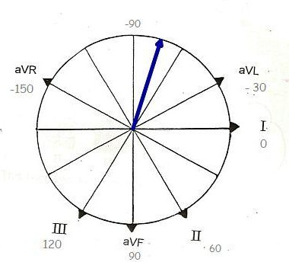a. If deflection is up, post left index finger up

b. If deflection is down, post left index figure down aVF

c. If deflection is up, point left index finger up

d. If deflection is down, point left index finger down

Look at Fingers

|  |  |  |
| --- | --- | --- |
| Left Hand | Right Hand | Conclusion |
| UP | UP | Normal axis (-30 to 100) |
| UP | DOWN | Left axis deviation |
| DOWN | UP | Right axis deviation |
| DOWN | DOWN | Extreme axis deviation |

Now, find the most isoelectric lead. The axis is 90◦ from this lead

*STEP 4: Intervals*

Normal Intervals:

PR: 0.12 – 0.20 sec

QRS: <0.12 secs

QT: 0.34 – 0.42 sec

*STEP 5: Hypertrophy*

|  |  |  |  |
| --- | --- | --- | --- |
| Right Atrial Enlargement (P pulmonale) | Left atrial enlargement (P mitrale) | RVH (right ventricular hypertrophy) | LVH (left ventricular hypertrophy) if QRS <0.12 sec |
| -Tall P >2.5mm in lead II  -Large diphasic P with large initial phase in V1 | -P >0.12 seconds  -Diphasic P with downward terminal phase in V1  -M-shaped P in I, II, or a VL | -RAD >110  -R > S in V1  -R in V1 >7mm  -S in V1 >2mm  -qR pattern in V1  -rSR’ in V1 with R’  >10mm | -R in 1 + S in III >25mm  -R in aVL >11mm  -R in aVF >20mm  -S in aVR >14mm  -R in V5 or V6 26mm  -R in V5 or V6 + S in V1  >35mm  -Largest R + largest S in precordial lead >45mm |

STEP 6: Infarction or Ischemia

Progression: Hyperacute T waves

ST segment elevation

Inverted T waves

Q wave (0.04 sec and/or >25% height of R wave)

|  |  |  |
| --- | --- | --- |
| **Location** | **Leads** | **Vessels** |
| Anterior | V2-V4 | LAD |
| Anteroseptal | V1-V4 | LAD |
| Anterolateral | V1-V6, 1, aVL | LAD, diagonal |
| Inferior | II, III and aVF | RCA, circumflex |
| Lateral | I, aVL, V5-V6 | Circumflex, diagonal |
| Posterior | Large R wave in V1-V3 | RCA |

STEP 7: Blocks

First degree: PR interval > 0.22 seconds

Second degree:

Mobitz Type I (Wenckebach): PR int increases until a QRS is dropped

Mobitz Type II: PR int constant, QRS randomly drops, more dangerous than type I.

- Pacemaker is recommended

Third degree: P waves at regular intervals, QRS complexes at regular intervals but **P waves and QRS waves are independent of each other**.

Bundle Branch Blocks:

RBBB: R-S-R’ in V1 or V2 >0.12 seconds

LBBB: R-R’ in I, V5 and V6

QRS >0.12 seconds

Wide S V1-V2

Absence of Q waves in I, V5 and V6

##### HEMATOLOGY

DVT (deep vein thrombosis): Initial signs of DVT include: erythema, warmth of the affected extremity. Duplex US combines the Doppler and compression methods and offers the quickest, most effective detection method available at the bedside. Upon confirmation of a clot, unfractionated heparin or LMWH therapy should be initiated.

A. UFWH

1. Loading dose = 80 units/kg

2. Initial infusion rate = 18units/kg

3. Draw PTT q6h and follow protocol. Titrate drip to maintain a therapeutic PTT ~60-90 Typical dosing for LMWH:

B. Lovenox: 1mg/kg bid or 1.5mg/kg daily

PE (pulmonary embolism): a clot or portion of a clot from an extremity breaks loose and enters the pulmonary circulation. Symptoms range from asymptomatic to respiratory arrest, depending on size and location of the clot. Manifestations may include dyspnea, tachypnea, hypoxemia. EKG: S1Q3T3 (non-specific)

Diagnosis of PE occurs in stages:

1. Lower extremity duplex scan. If positive, a PE is presumed, and therapy initiated

2. V/Q scan: overall lung parenchyma must be fairly normal otherwise will be difficult to interpret

a. Normal results exclude PE.

b. Low-probability with a negative duplex scan indicated PE is unlikely.

c. Indeterminate results are of no value and indicate further testing is necessary

3. Contrast Enhanced CT scan of chest may allow visualization of a thrombus or suggest alternative diagnosis

4. D-dimer cannot be used as a sole testing method. Negative results may help rule out PE along with other testing methods, but a positive result had no predictive value

5. Pulmonary angiography is the gold standard but caries the greatest risk because of its invasiveness

Treatment options:

**If suspicion is high, start therapy prior to testing**

1. Unfractionated heparin (same dose as per DVT)

2. LMWH (same as per DVT)

3. Thrombolytics (9TPA, reteplase, alteplase)

4. IVC Filters

5. Thrombectomy/Transvenous catheter emboli excretion

Secondary prophylaxis involves the administration of anticoagulants to prevent recurrent of thrombotic events. Warfarin is commonly used and must be administered simultaneously with heparin until an INR of 2-3 is achieved. LMWH has also proven successful at secondary prophylaxis but involves greater expense and patient willingness to administer their own subcutaneous injections.

**Duration of therapy is 3 months whether provoked or unprovoked. If unprovoked and bleeding risk is low, then anticoagulation can be continued indefinitely**

**Thrombolysis:**

-Indication: Persistent hypotension or shock due to acute PE. Need to take the whole clinical picture into consideration.

- in most cases, systemic thrombolytic therapy should be considered only after acute PE has been confirmed because the adverse effects of the therapy can be severe

**\*\*If a patient is going to need mechanical thrombolysis the ICU must be made aware**

|  |  |  |
| --- | --- | --- |
| Possible indications | Contraindications | Relative contraindications |
| --severe or worsening right ventricular dysfunction  --cardiopulmonary arrest due to PE  --extensive clot burden | --high risk of bleeding  --intracranial neoplasms  -- <2 months intracranial or spinal surgery or trauma  -- history of hemorrhagic stroke  --ischemic stroke in <3 months | --severe, uncontrolled BP (SBP  >200 or DBP >110)  --ischemic stroke >3 months  --pregnancy  --recent bleeding 2-4 weeks  --surgery within one month  --current use of anticoagulation  --age >75 |

Oral Anticoagulants:

|  |  |  |  |  |  |
| --- | --- | --- | --- | --- | --- |
| Medication | Warfarin/  Coumadin | Dabigatran/  Pradaxa | Rivaroxaban/  Xarelto | Apixaban/  Eliquis | Edoxaban/  Savaysa |
| Approved Indications | --stroke prevention in afib or prosthetic heart valves  --DVT/PE ppx and tx | --stroke prevention in nonvalvular afib  --VTE ppx in hip/knee replacement  --DVT/PE tx  --DVT/PE ppx of recurrence | --stroke prevention in nonvalvular afib  --VTE ppx in hip/knee replacement  --DVT/PE tx  --DVT/PE ppx of recurrence | --stroke prevention in nonvalvular afib  --VTE ppx in hip/knee replacement  --DVT/PE tx  --DVT/PE ppx of recurrence | --stroke prevention in nonvalvular afib  --DVT/PE tx |
| Mechanism of Action | Vitamin K antagonist. Inhibits vit K dependent clotting factors (II, VII, IX, X) &  Protein C and S | Direct Thrombin Inhibitor | Factor Xa inhibitor | Factor Xa inhibitor | Factor Xa inhibitor |
| Onset of Action | Slow onset; 5 to 7 days | Rapid onset; about  2 hours | Rapid onset; above  2.5 to 4 hours | Rapid onset;  about 3 hours | Rapid onset; about  0.5 to 2 hours |
| Elimination | Hepatic | 80% renal | 33% renal | 25% renal | 50% renal |
| Renal Adj. | No | Yes | Yes | Yes | Yes |
| Monitoring | INR | Routine lab monitoring not required: aPTT, ECT (if available), TT (most sensitive) may be used to detect presence of  dabigatran | Routine lab monitoring not required, may use PT to detect presence of rivaroxaban | Routine lab monitoring not required, PT, INR and aPTT may be used to detect presence of apixaban | Routine lab monitoring not required |
| Reversal agent | Vitamin K  For major bleeding: consider PCC with vitamin K, FFP | Idarucizumab  Dabigatran is 60% dialyzable  Activated charcoal may be used if ingestions occurred in <2 hours prior to  presentation | Andexanet alfa – not usually available; for major bleeding consider PCC or recombinant factor VIIa3  Not dialyzable | Andexanet alfa – not usually available; for major bleeding may consider PCC or recombinant factor VIIa  --Not dialyzable  --Activated charcoal may be used if ingestion occurred within 2- 6 hours of presentation | No specific antidote  Edoxaban is not dialyzable |

Disseminated Intravascular Coagulation: DIC

The release of tissue factor from endothelial injury that activates clotting cascade. If systemic = disseminated intravascular coagulation. Results in widespread microvascular thrombosis and can be accompanied by fibrinolysis (simultaneous coagulopathy and bleeding diathesis). Sepsis, particularly with gram negative organisms, is the most common scenario. DIC may manifest as ARDS, kidney or liver dysfunction, or GI bleeding. Diagnosis of DIC: correlation of clinical picture with coagulation studies. Typically, results are as follows:

|  |  |
| --- | --- |
| PT | Increased |
| PTT | Increased |
| Platelet count | Decreased |
| D-Dimer | Positive |
| Fibrinogen | Decreased |
| INR | Elevated |

Treatment consists of the following measures:

1. Treat the underlying disorder
2. Administer cryoprecipitate to replace fibrinogen. Monitor for response of INR
3. If no correction of INR, administer FFP
4. If necessary, transfuse platelets.

Heparin Induced Thrombocytopenia (HIT)

1. Occurs when antibodies are formed against the heparin-platelet factor 4 complex.
2. Characterized by a 50% fall in platelet count from baseline or to <150,000
3. Typically occurs in 4-5 days after onset of heparin therapy
4. Can also occur with patients on LMWH (lovenox)
5. If evidence of thrombosis – patient should be started on direct thrombin inhibitor
   * 1. Argatroban
     2. Bivalirudin – for pts undergoing PCI and have HIT or are at risk of HIT
6. Don’t transfuse platelets – because can worsen thrombosis
7. Only transfuse if severe thrombocytopenia who are bleeding or undergoing an invasive procedure
8. Fondaparinux and NOAC have not been approved for the treatment of HIT
9. Duration of treatment:
10. If only thrombocytopenia: treat for 4 weeks
11. If thrombosis: treat for 3 months with warfarin.
    1. Warfarin shouldn’t be started until plt > 150K
    2. Argatroban with warfarin until INR therapeutic x 48 hrs

**BLOOD COMPONENT THERAPY**

|  |  |  |  |
| --- | --- | --- | --- |
| **Component** | **Content** | **Indications** | **Results** |
| Packed Red Blood Cells (pRBCs) | ~200 mL red blood cells | Active bleeding Hgb <7 | 1 unit of pRBCs raises  Hgb by ~ 1 mg/dL . Depends on patient size. |
| Platelets (typically given as “6 pack” which is 1 unit) | 1 unit contains 50-100 billion platelets | <10K  <20K + fever  <50K if bleeding, planned procedure  <100K if intracranial  bleed | Single unit raises platelet count by 5000 – 10000/mm3  **varies** |
| Fresh Frozen Plasma (FFP) | All coagulation factors | Bleeding due to coagulation factor deficiency if increased  INR (>2) | 3-4 units will typically raise the factor levels by 15% |
| Cryoprecipitate (cryo) | Factor VIII, vWF, and fibrinogen | Hemophilia, vWD, Fibrinogen <100 | Raises fibrinogen by 25mg/plasma volume of  infusate |
| Prothrombin complex  concentrate (PCC) | Factor II, VII, IX, X,  protein C and S | Active bleeding on  anticoagulation | **c/i in DIC |
| Transexamic acid | Antifibrinolytic | Hemophilia, heavy menstrual bleeding, post  op surgical bleeding |  |

**Transfusion Reactions**

|  |  |  |  |
| --- | --- | --- | --- |
| Reaction | Cause | Manifestation | Treatment |
| Acute hemolytic | Pre-formed antibodies | Quick onset fever, chills, chest pain, low back pain, and possibly hypotension | -STOP transfusion & return remaining blood to lab  - IV fluids for clearing hemolysis products  - maintaining UOP >100mL/hr  -Consider urine alkalinization with sodium bicarbonate |
| Delayed hemolytic | Formation of new antibodies or amnestic response | Within 3-4 weeks of transfusion, Hct falls and  bilirubin rises |  |
| Non-hemolytic, febrile | Reaction to antibodies to done plasma proteins or  WBCs | Fevers, chills, urticarial, pruritus, respiratory distress | Tylenol Benadryl |
| Volume overload | In patients with CHF, infused volume may cause pleural effusions | Dyspnea | -slow infusion  -Lasix 40mg IV midway through infusion, if patient  can tolerate |

##### Intensive Care Unit

##### ORGANIZATION OF NOTES

(*) Take pride in your notes. These are important medico-legal documents and reflect your thinking and practice. These are important in resident evaluation as well. Please do not copy and paste forward notes. Edit them to keep them relevant and factual.

ADMISSION NOTE:

Should include all of the following:

HPI – including the traditional elements: in addition to a brief summary of what has been done to the patient since his/her presentation to the hospital, whether she is being transferred from the ED, floor or outside hospital.

**If the patient is admitted from the ED, the history should include time of presentation, medications admitted in the ED, quantity/type of fluid administered, admission labs and reason for transfer to ICU.

**If the patient was admitted from the floor/OSH, include a brief overview of the hospital stay and reason for transfer.

Past Medical History

Past Surgical History

Family History Social History

Home meds/Allergies Focused ROS

All fluids/continuous drips (ex. NS @125cc/hr, Levophed 10mcg/kg/min) Ventilator Settings

Vitals/Physical Exam Labs/Micro/Imaging

A/P - listed by organ system

Neuro: Level of consciousness, RAAS score. (Not Intubated/sedated) EENT:

Pulm:

CV:

Renal:

ID: (include day of Abx, ex: Vancomycin – day 2) GI: (include nutritional information here)

Endo: Heme:

The checklist is a way to tie up important things that tend to be forgotten in the ICU and has been shown to have mortality benefits.

**Checklist:**

- Medication list reviewed with the Clinical Pharmacist:

- Volume Balance: address goal volume balance for the next 24h

- Lines/Tubes: what kinds of lines they have and where, and date they were placed and whether still required or can be removed. (DC lines as soon as possible)

- Lung protective ventilation: (yes, no or n/a) if no state why

- DVT PPX:

- Pressure PPX: walking, turns q2h, specialty mattress

- GI PPX if indicated: H2B or PPI or n/a

- Sedation:

- Analgesia:

- Antibiotics/Start date:

- FEN: if NPO state why

- Mobility/PT-OT:

- Family updated:

PROGRESS NOTES:

S: Hospital day #, any overnight events as reported by the patient, overnight team or nursing staff

O: Vitals usually in ranges and MAP

Net fluids – I/O (categorize output from any drains) Ventilator settings

Exam

ABGs (pH, pCO2, PO2, FiO2, P:F)

Labs/Micro Imaging Medications

A/P: same as above

Checklist: same as above

PRESENTATIONS:

Hospital Day/MICU day

Overnight events

Vitals

I/O

Ventilator settings

Physical exam

Pertinent labs

Micro/Imaging

A/P by systems

Checklist

Tips:

-Call consults early in day and follow up with their recommendations.

-Each afternoon prior to leaving:

**follow up on any new recommendations from consultants, as well as labs/imaging results (esp new Micro data)

**order appropriate morning labs on all your patients: ABG/VBG, CXR, etc

** talk to your team about procedures, notes, or other needs.

##### ICU PROPHYLAXIS

**GI Prophylaxis**

Stress ulcers represent disruptions in the superficial GI mucosa from inadequate blood flow that normally permits regeneration of mucosal tissue. This can cause stress-related mucosal bleeding from the upper GI tract. Therefore, stress ulcer prophylaxis is commonly administered to critically ill patients for the prevention of mucosal bleeding.

Stress ulcer prophylaxis should be limited to high risk patients:

Mechanical ventilation >48 hours

Vasopressors

Coagulopathy (platelet count <50 or INR >1.5)

Methods to prevent the formation of ulcers are:

Enteral feeding

Use of acid-reducing drugs Therapy:

*H2 blocker preferred unless PPI home med or treating GI bleed *

Famotidine 20mg IV BID or daily if renally insufficient

Pantaprazole 40mg IV

*Once extubated and/or off vasopressors, discontinue GI prophylaxis, unless home med or receiving treatment for a GI bleed*

**DVT Prophylaxis**

All ICU patients have PE/VTE risk because of immobility and critical illness. Every patient should be on chemical prophylaxis, unless contraindicated:

- Active or suspected bleeding

- Thrombocytopenia (relative contraindication)

Chemical prophylaxis:

Heparin 5000 units SQ TID or Lovenox 40mg SQ daily if GFR>30.

Sequential Compression Devices (SCDs): provide repetitive external compression to the lower legs to facilitate venous return.

- SCDs unless on chemical prophylaxis or contraindicated:

o Severe swelling

o Lower extremity ulcers/burns (Consider upper limb SCDs)

**ICU Psychosis/Delirium**

Experienced in ICU or critically ill patients resulting in cluster of serious psychiatric symptoms. Worsened short and long-term outcomes and increased mortality.

Risk Factors and Causes:

- Medical Illness, advanced age, known neuro or psych disorder.

-Environmental: Unfamiliar environment, day/night cycle disruption, sunlight exposure, isolation, away from family and friends.

-Sleep deprivation: disturbance of hospital staff checking vitals, giving medications, baths etc. Alarms, light, and noise.

-Medications: BZD, other sedatives, analgesics, antibiotics, continuous medical monitoring with alarms.

Prevention/Treatment:

- Frequent reorientation (even if sedated)

- Keep lights on during the day, window blinds open, TV on

- Keep light off at night, TV off, minimize night disturbances

- Encourage family visits

Data limited about pharmacologic treatments: typical and atypical sedatives are commonly used in agitated patients.

**(*) Hypoactive delirium is much more common than hyperactive delirium**

##### ICU PULMONARY

**Supplemental Oxygen**

1. Low flow oxygen devices: usually < 6L/min. These devices provide pure oxygen as a fraction of the minute ventilation. The remainder is filled by room air. Oxygen delivery is dependent on respiratory effort and minute ventilation. These devices are:

|  |  |  |  |
| --- | --- | --- | --- |
| **Device** | **Flow Rate** | **FiO2** | **Comments** |
| Nasal Cannula | 1-6 L/min | 24 – 44% | Flows above 6L/min don’t  increase FiO2 >.44 |
| Oxygen Mask | 6-10 L/min | 35 - 60% | Ex. Misty ox, simple face mask |
| Reservoir Cannula | 1-6 L/min | 24 – 50% | Ex: Oxymizer (mustache) or  oxymizer pendant form;  designed to conserve O2 |

2. High flow oxygen devices: Meet or exceed inspiratory demands.

|  |  |  |  |
| --- | --- | --- | --- |
| **Device** | **Flow Rate** | **FiO2** | **Comments** |
| Venturi Mask | 4-12L/min | 24-50% | Delivers a precise O2 concentration, therefore CO2 retention is minimal |
| High flow NC | 5-60 L/min | Up to 60% |  |
| Non Rebreather | 10-15L/min | 60% |  |
| Opti-flow | 60L/min | Up to 100% | Good for use in pts with contraindications to NIV therapy and also provides some ventilatory support. (some positive pressure which cannot be quantified) |
| Vapotherm | 40L/min | Up to 100% | Same as above |

**Respiratory Failure**

Inadequate gas exchange due to dysfunction of one or more essential components of the respiratory system.

**4 Types of Respiratory Failure**

**Type 1: hypoxemic (PaO2 <60) – Failure of oxygen exchange**

Hypoventilation: drug overdose, chest wall trauma, muscle weakness, stroke or brain tumor involving the respiratory center, OHS

* + Frequently associated with hypercapnia

Diffusion Limitation: scarring or abnormally thickened blood/gas barrier such as pulmonary fibrosis or other forms of interstitial lung disease

Shunt: respond poorly to increased FiO2

* + Anatomic shunt: pulmonary AVMs or intra-cardiac shunt
  + Physiologic shunt: severe PNA with ARDS

V/Q mismatch: most common. Mismatch ventilation and blood flow impairs the uptake or elimination of gases by the lung

* + Ventilation also affected – may have component of type 2

High altitude: Low partial pressure of oxygen. Normal A-a gradient

**Type 2: Hypercapnic / Ventilatory (PaCO2 >45 or more than expected)** **– Failure to exchange or remove carbon dioxide**

- Due to a decreased minute ventilation relative to demand

- Increased dead space ventilation

- Central hypoventilation

- Neuromuscular diseases

- Obstruction (COPD/Asthma/OHS)

**Type 3: Peri-operative – increased atelectasis due to low functional residual capacity.**

- Post-operative analgesia / Splinting (especially with upper abdominal wall incision)

- Obesity, ascites

- Pre-operative tobacco smoking

- Excessive airway secretions

- Undiagnosed OSA

- Anesthetic and analgesic medication effect

**Type 4: Shock**

* + - * + The goal of ventilation in this setting is to stabilize gas exchange, unload the respiratory muscles, lowering their oxygen consumption and for severe acidosis

##### Non-invasive positive pressure ventilation

**1.CPAP (continuous positive airway pressure)**

- delivery of a continuous level of positive airway pressure. Functions similar to PEEP.

- patients must initiate all breaths

- no additional pressure above the level of CPAP is provided

- commonly used for OSA

2.**BIPAP (bi-level positive airway pressure)**

-Unlike CPAP, respiratory pressures are augmented.

-Inhalation positive airway pressure (IPAP) and the exhalation positive airway pressure (EPAP) are adjusted for optimization of ventilation.

-the tidal volume usually correlates with IPAP and EPE difference.

Ex. IPAP 15 & EPAP 5; tidal volume generated based on pressure of 10

Ex. IPAP 10 & EPAP 5, tidal volume generated based on the pressure of 5

**Indications**:

- Congestive heart failure

- COPD exacerbations (esp hypercapnea)

- Asthma exacerbation (use with caution, very limited data)

- OHS/OSA

- Neuromuscular weakness

- pre-oxygenation prior to intubation

- Intubation refusal

- Post Extubation in select patients

**Contraindications**:

- Need for emergent intubation

- Altered mental status, inability to protect airway (high aspiration risk)

- Inability to tolerate mask, cooperate

- Active vomiting

- Cardiac or respiratory arrest

- Hypoxemic respiratory failure due to pneumonia (relative contraindication)

**if AMS thought from hypercapnic encephalopathy, consider trial of NPPV. Monitor patient closely. If no improvement w/in ~1-2 hrs, patients should be promptly intubated.**

##### Invasive Mechanical Ventilation

Indications:

Apnea

Respiratory failure

Impending respiratory failure

Inadequate oxygenation

Inability to protect airway

**Modes**:

1.AC/VC – assist control/volume control

Variables:

- TV (tidal volume) – usually set at 6-8cc/kg of ideal body weight

- RR – respiratory rate

- PEEP – positive end-expiratory pressure: the pressure at end-expiration required to keep the alveoli patent / augment FRC

- FiO2 – amount of inspired oxygen

In this mode, ventilator delivers min. number of breaths (set rate) with set tidal volume. Breath at set tidal volume can be patient triggered or machine delivered. Look for ventilator synchrony. Keep a close eye out for the ventilator pressures.

2.AC/PC – assist control/pressure control

Variables:

- Inspiratory Pressure (Pi): pressure delivered during inspiration

- RR – respiratory rate

- PEEP – positive end-expiratory pressure: pressure at end-expiration required to keep the alveoli open

- FiO2 – amount of inspired oxygen

In this mode, tidal volume varies. Based on compliance of the lungs. Tidal volume delivered (mandatory or patient triggered) is based on driving pressure OR Pi – PEEP.

Compliance is lungs ability to stretch and expand. Poor compliance (stiff lungs) requires higher Pi to deliver an adequate tidal volume. As the patient improves (lungs are more compliant) and lower Pi is used to deliver the same tidal volume. Compliance changes over minutes to hours to days thus close monitoring of tidal volume is essential.

3. PS - Pressure Support

Variables:

- PEEP

- Pressure support – similar to Pi: pressure delivered in inspiration

- FiO2

Patient initiates every breath. No mandatory breaths by ventilator. Tidal volume determined by set pressure support and PEEP. If apneic, ventilator has back-up mode and will return to previous mode settings.

4.SBT – spontaneous breathing trial

- essentially pressure support mode with pressure set at 5.

- SBT done for at least 30 minutes prior to extubation (see below for more details)

5.T piece trial

- a form of SBT when patient is disconnected from ventilator and placed on blow-by supplemental oxygen.

- Done in high risk patients prior to extubation (low EF, neuromuscular weakness, etc)

**Less commonly used modes of ventilation in the MICU:**

6.SIMV – synchronized intermittent mandatory ventilation

Variables:

- TV (tidal volume) – usually set at 6-8cc/kg of ideal body weight

- RR – respiratory rate

- PEEP – positive end-expiratory pressure

- FiO2 – amount of inspired oxygen

- Support – either pressure or volume

Similar to AC/VC. But patient initiated breath is unassisted. Tidal volume delivered varies based on pressure support set.

7.APRV – airway pressure release ventilation

Salvage mode used in certain circumstances: i.e. difficult to oxygenate. Effectively inverse ratio pressure control.

Variables:

- P-high and P-low to determine driving pressure (VT will depend on pulmonary compliance)

- T-high and T-low to determine time at each pressure

- RR – respiratory rate

- FiO2 – amount of inspired oxygen

- Wean by “drop and stretch” – slowly lowering P-high pressure and/or time on P-high

In modes based on pressure control (AC/PC and APRV), keep an eye on MVe (minute ventilation) and tidal volumes as these modes do not guarantee a tidal volume delivery and you risk under-ventilation.

**Criteria for Extubation:**

1. Reason for mechanical ventilation has resolved

2. Awake, able to follow commands (adequate mental status)

3. Minimal secretions

4. Acceptable hemodynamics (ideally off vasopressors)

5. PEEP is set at 5 and FiO2 is <50% with adequate oxygenation

6. Pass SBT: must be on this mode for 30 minutes

a. RSBI (rapid shallow breathing index) = RR/TV (in L).

**< 105 🡪 Unlikely to need re-intubation**

Ex. On SBT: RR 34 BPM & average tidal volume of 300cc.

RSBI = 34/0.3 = 113 🡪 high chance of failing extubation

Ex. Following day, during SBT, RR 22 bmp & TV450cc.

RSBI = 22/0.45 = 49 🡪Extubate!!

**During an SBT, pay attention to hemodynamics (blood pressure, heart rate). If a patient becomes extremely tachycardic and/or hypotensive caution should be taken with extubation. **

##### Acute Respiratory Distress Syndrome (ARDS)

ARDS is characterized by widespread lung inflammation from activation of inflammatory cascade resulting in diffuse alveolar injury and surfactant dysfunction. Impairs gas exchange and has high mortality.

Many causes, with examples:

-pneumonia/aspiration -pancreatitis

-sepsis -inhalation injury/drowning

-trauma/pulmonary contusion -severe burns

-sepsis/septic shock -TRALI

-drug overdose

Berlin Criteria for diagnosis of ARDS

- Timing: <1 week onset

- Imaging: bilateral lung opacities

- Origin of edema: respiratory failure is not fully explained by cardiac failure or fluid overload

- Oxygenation: based on PaO2/FiO2

* Mild: P/F <300
* Moderate: P/F <200
* Severe: P/F <100

Treatment: Treat the underlying cause. Lung Protective Ventilation.

ARDS are particularly susceptible to lung injury from mechanical ventilation: volutrauma, barotrauma and atelectrauma.

Lung Protective Ventilation includes:

1. Tidal Volume: 6-8cc/kg Ideal body weight (min 4 cc/IBW)

2. Plateau pressures must be <30cmH2O

a. Plateau pressure = pressure applied to small airways and alveoli. Measured from inspiratory hold.

3. Wean FiO2 <60% in first few hours by increasing PEEP.

FiO2 >60% for > 24hrs may cause lung injury.

Follow ARDSnet protocol for High PEEP; low FiO2 (see chart below)

Other Therapies: If high PEEP and FiO2 and unable to oxygenate,

1. Proning (improves mortality if done early; 16 hours a day)

2. Paralytics (mortality benefit in early ARDS)

3. APRV

4. iNO/Flolan (limited data)

5. ECMO

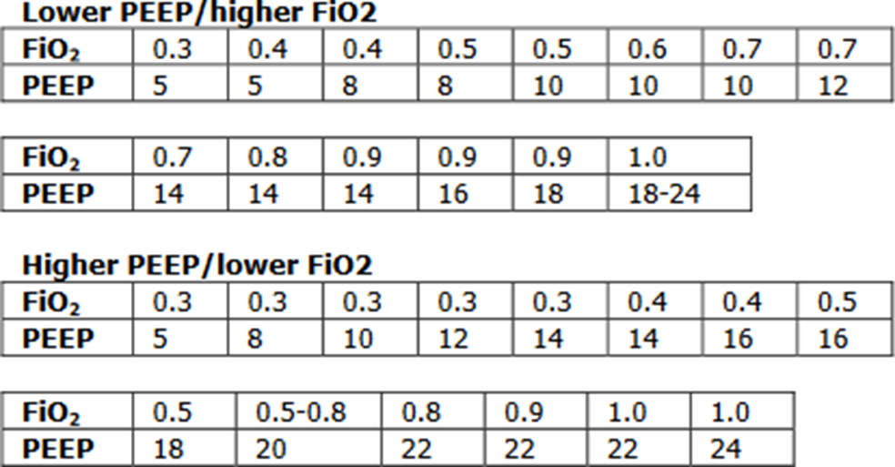

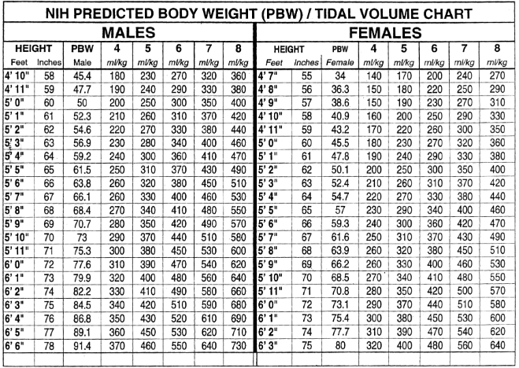

##### Trouble shooting high peak pressures:

PIP: peak inspiratory pressures – Max pressure during inspiration measuring **airway resistance and lung compliance**.

Plateau pressure: pressure applied to small airways and alveoli. Applying an inspiratory hold measuring **lung compliance.**

If high peak pressures but plateau <30 =Increased airway resistance

1. Kinked ET tube, or pt is biting down on ET tube

2. Mucous plug/excessive secretions

3. Bronchospasm

4. Water in the tubing system

Both peak & plateau pressure elevated = Decreased Pulm Compliance:

1. Pulmonary edema

2. Hemothorax/worsening pleural effusion

3. Ascites/abdominal compartment syndrome

4. Tension pneumothorax

5. Worsening consolidation/ARDS

##### Acid/Base

General Rules:

1.Always consider the clinical scenario.

2.You need both an ABG and a renal panel to fully evaluate.

3.Normal values

pH: 7.35 - 7.45 --> normal 7.40

pCO2: 35 - 45 --> normal 40

pO2: 80 - 100

bicarb: 24 - 28

Anion gap: 8 - 12 (must correct for albumin; every 1g albumin below normal (normal = 4), expected AG drops by 2.5)

5.The body can never over compensate for primary acid-base disorder.

6.Respiratory compensation is fast (minutes to hours)

7.Metabolic compensation is slow (days)

**STEP 1**: Identify primary process – Is pH up or down?

Elevated (>7.40): Alkalosis

Decreased (<7.40): Acidosis

**STEP 2**: What is the primary process?

Is pH and pCO2 abnormality in the same direction (i.e. both elevated or both decreased)?

Yes – primary metabolic disorder

Metabolic acidosis: HCO3 <24 or alkalosis: HCO3 >24

No – primary respiratory disorder

Respiratory acidosis: paCO2 >45 or alkalosis: paCO2 <35

**STEP 3**: If primary metabolic disorder, calculate Anion Gap

**STEP 4**: If anion gap, calculate delta gap for other metabolic processes

**many people do this differently, this is one method**

[calculated AG – 12] + measured HCO3 = corrected bicarb

--if corrected bicarb is >24 then metabolic alkalosis co-exist

--if corrected bicarb is <24 then NAGMA co-exist

--if corrected bicarb = 24 no other metabolic process exist

**STEP 5** If main disorder is respiratory, is it acute or chronic?

Acute (<8hrs) expected ∆pH = 0.008 x (40 -pCO2)

Chronic (>24hrs) expected ∆pH = 0.003 x (40 - pCO2)

**STEP 6** If metabolic acidosis present, is respiratory compensated? Winter’s Formula =(1.5 x serum HCO3) + 8 = expected pCO2 +/- 2

--If pCO2 is < expected = resp alkalosis

--if pCO2 is > expected = resp acidosis

**STEP 7** If isolated metabolic alkalosis, is compensated?

--if pCO2 <40, also resp alkalosis

--if pCO2 >50, also resp acidosis

--if pCO2 = 40 - 50, normal resp response

Metabolic

|  |  |  |
| --- | --- | --- |
| Increased AG acidosis | Normal AG acidosis | Alkalosis |
| -Methanol  -Uremia  -DKA  -Paraldehyde  -INH  -Lactic acidosis  -EtOH  -Ethylene glycol  -Salicylates -Rhabdo | -RTA  -NS induced- hyperchloremia | -Diuretics  -Licorice  -Vomiting  -Diarrhea  -NG suction  -Refeeding syndrome  -Conn’s/Cushing’s  -Barter’s |

Respiratory

|  |  |  |
| --- | --- | --- |
| Acute Acidosis | Chronic Acidosis | Alkalosis |
| Anything Causing Hypoventilation  -CNS depression (opoid overdose)  -Airway obstruction  -pneumonia  -pneumothorax/hemothorax  -pulm edema  -mechanical hypoventilation | -COPD  -restrictive lung disease  -neuromuscular disorders | -CNS disease (trauma, CVA, ICH)  -encephalopathy  -anoxic brain injury  -anxiety  -sepsis  -hypoxia  -salicylates -mechanical hyperventilation |

##### Procedures

**Central Lines**

* Important way to get access if unable to obtain peripheral access
* Important for pressors to reduce risk of peripheral vasospasm and necrosis
* 100% sterile procedure
* IJ safest in a patient on positive pressure ventilation and in very thin patients. Large neck may be technically challenging
* Femoral may be a good consideration in a patient with very high risk of bleeding as it is a compressible location

*Prior to starting the procedure ensure informed consent is obtained

*Locate the U/S and identify target vessel

*Obtain sterile equipment

*Video demonstrating technique:

<https://www.youtube.com/watch?v=HE5QhsPRaPU>

**Paracentesis**

**Indications:** diagnose cause of ascites, evaluate for infectious process, symptomatic relief

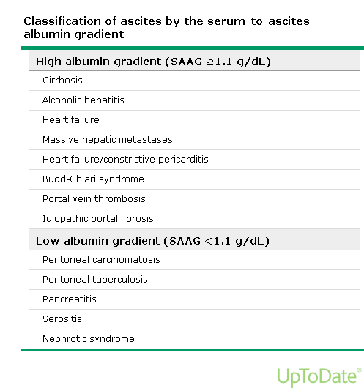**Complications:** pain, bleeding, infection, bowel perforation, liver/spleen laceration, persistent leakage of fluid

*Prior to starting the procedure ensure informed consent is obtained

*Locate site for puncture with U/S. Perform Doppler prior to needle insertion

*Obtain sterile equipment

*If you are doing a diagnostic paracentesis only you do not need the paracentesis kit. Can use 50 cc syringe and needle.

Labs: Serum Albumin, Fluid Albumin, fluid total protein, culture (in aerobic and anaerobic blood culture bottles), glucose, LDH, gram stain, amylase, AFB, cytology, +/- triglyceride, bilirubin, serum BNP

*Video demonstrating technique

<https://www.nejm.org/doi/full/10.1056/NEJMvcm062234>

**Lumbar Puncture**

**Indications:** infectious process, subarachnoid hemorrhage evaluation with negative CT, assessing the etiology of a headache or fever of unclear origin

**Complications:** pain, bleeding, infection, post-procedure headache, brain herniation, persistent leakage of fluid

**Contraindications:** Alteration in mental status or focal neuro deficits should get a non-con CT of the head first to assure no elevated intracranial pressure; if this is the case, start the antibiotics before the CT and do the procedure immediately afterward – never wait to start antibiotics if you suspect bacterial meningitis for any reason!!

*Prior to starting the procedure ensure informed consent is obtained

*Obtain sterile equipment

*Video demonstrating technique

<https://www.nejm.org/doi/full/10.1056/NEJMvcm054952>

Studies to be sent:

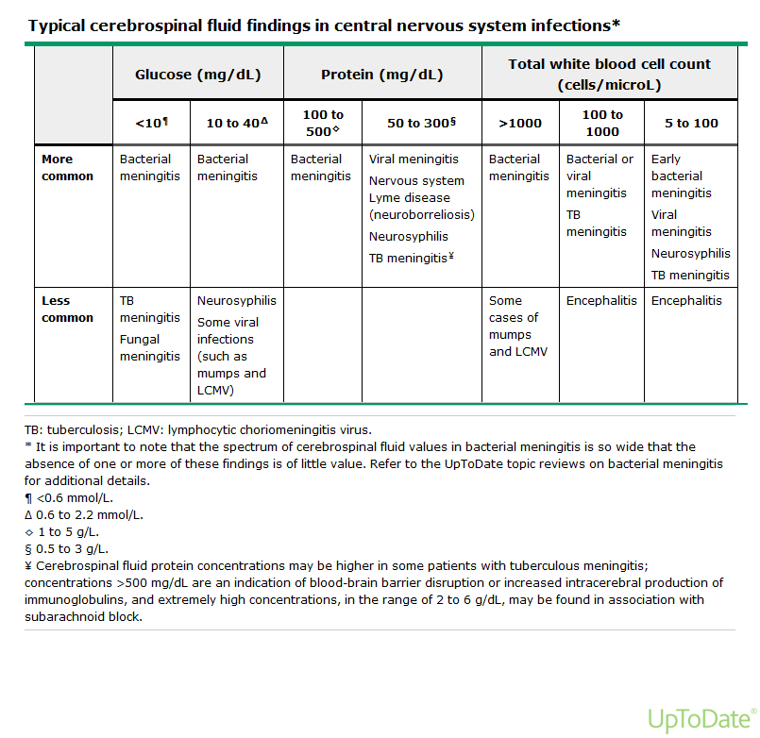**Tube #1: cell count and diff; Tube #2: glucose, protein, VDRL; Tube #3: culture and gram stain (any special studies should be added to this one including cytology, TB, viral panels, crypto latex agglutinin); Tube #4: cell count and diff (again)**

**Thoracentesis**

**Indications:** therapeutic relief of dyspnea, diagnosis of unknown effusion, removal of parapneumonic effusion, concern for infected or malignant fluid

**Possible Complications:** pain, bleeding, infection, hemothorax, pneumothorax, costal nerve damage, damage to liver or spleen

*Prior to starting the procedure ensure informed consent is obtained

*Locate site for puncture

\***Recall VAN complex on the lower aspect of each rib**

**\*Don’t insert needle below the 9th rib**

*We usually avoid removing more than 1.5K at a time to try and avoid reexpansion pulmonary edema

*Obtain sterile equipment

*Video demonstrating technique

<https://www.youtube.com/watch?v=ivTyH09BcHg>

**Pleural Effusions:**

Common Causes:

**Exudate**

- Infection

- Malignancy

- PE

- Hemothorax

- Chylothorax

**Transudate**

- CHF

- Cirrhosis

- Nephrotic syndrome

- Hypoproteinemia

Light’s Criteria: (One or more true, fluid is exudative)

- Pleural protein/serum protein >0.5

- Pleural LDH/serum LDH >0.6

- Pleural LDH > 2/3 upper limit of normal for serum LDH

Empyema: pH <7.20; gram stain +, culture + or frank pus

**Indication for chest tube placement

**Complicated parapneumonic effusion**:

Exudative, predominantly neutrophilic. Low glucose (<60). Elevated LDH. Fluid is cloudy. Typically requires a chest tube for drainage.

**Uncomplicated parapneumonic effusion**:

Exudative, predominantly neutrophilic. Fluid maybe clear or slightly cloudy but gram stain and culture are negative. They normally resolve with antibiotics alone

**Other causes of decreased pH** (<7.20): rheumatoid arthritis, esophageal rupture

**Chest Tube Indications**:

1. pneumothorax

2. empyema, complicated pleural effusion

# Definitions for chest tube management:

Atrium: See picture below. What is connected to the chest tube & where the fluid is collected.

Suction: suction tubing connects to the atrium and then to wall suction. To know the chest tube is actually to suction, the orange accordion will show through window in the upper left corner. Suction is usually set at -20. When a chest tube is first placed, it is usually connected to suction, especially if it was placed for management of a pneumothorax.

Water seal: when no suction is connected. The orange accordion will not be visible. Usually the tube should be on water seal prior to removal.

Clamped: the tubing is clamped. This is not always done, but in high risk patients the tube will be clamped to ensure fluid (effusion) or air (pneumothorax) does not re-accumulate. This is a representation of not having the tube in place.

**Air leak**: if an air leak is present, bubbles will be seen in the bottom left corner every time the patient take a breath. This indicates the presence of a pneumothorax or bronchopleural fistula.

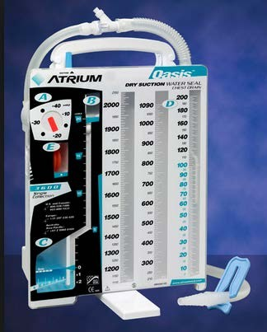

Video: <https://www.youtube.com/watch?v=MAeum5dlZFo>

# SEDATION

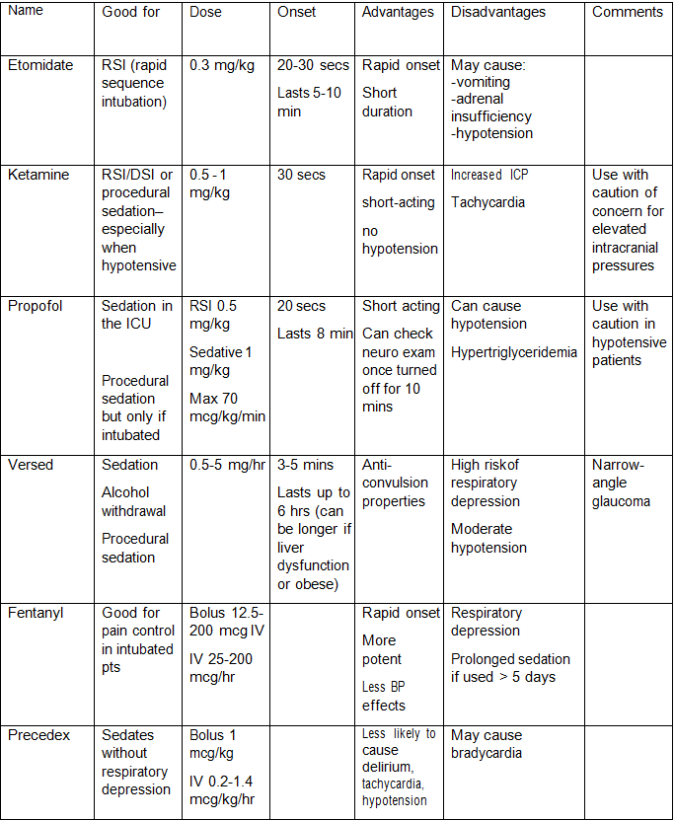

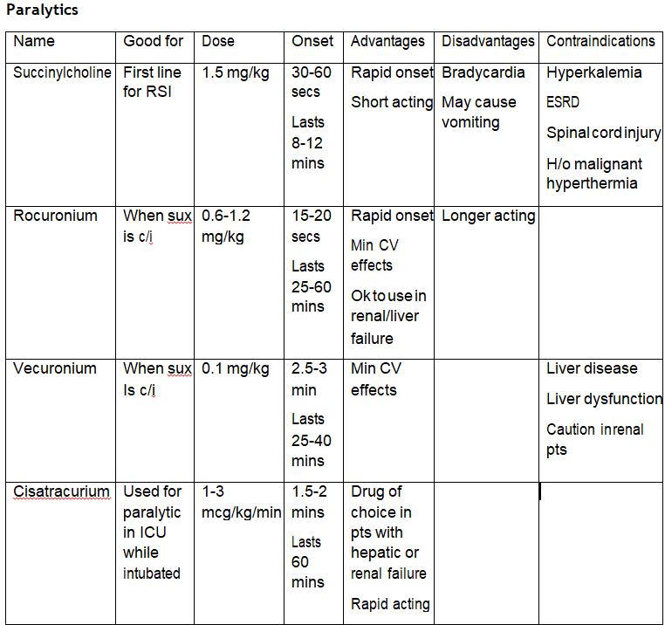

##### ABCDE Bundle

Group of evidence-based interventions divided into 3 components to prevent complications of critical illness.

**ABC – Awakening and Breathing Trial Coordination**

Daily sedation vacations decrease overall ICU length of stay by decreasing ventilator days and hospital acquired complications. Over-sedation and under-sedation can lead to prolonged ventilator times. The Bundle addresses sedation vacation and Spontaneous Breathing Trials to promote earlier extubation

**D- Delirium Assessment and Management**

All patients are susceptible to delirium. Unfortunately, often goes undetected and untreated leading to long-term consequences. Early identification and management of delirium

**E – Early Exercise and Progressive Mobility**

Prolonged bedrest or immobility are prone to developing muscle weakness and atrophy and can increase hospital stay and long-term muscle dysfunction. The “E” bundle encourages progressively more activity and possibly walking while intubated.

As a team, focus on the “ABC” portion of the bundle in order for “D” and “E” to fall in place. Every morning a sedation vacation should be attempted unless:

**Contraindications:**

Active seizures

Active alcohol withdrawal

Paralyzed patients

**Relative contraindications:**

high amounts of pressures/FiO2

If no contraindication, sedation should be stopped, and patient monitored closely. During this time neurologic status should be evaluated. If following commands, SBT should be performed.

Examples of Sedation Vacation Failures

Anxiety/agitation: try fentanyl bolus

RR >35

O2 sat <88%

Respiratory distress

Hemodynamic instability/arrhythmia

##### ICU References

Doherty DE, Petty TL, Bailey W, et al. Recommendations of the 6th long-term oxygen therapy consensus conference. Respir Care. 2006; 51(5):519-525.

Kory RC, Bergmann JC, Sweet RD, et al. Comparative evaluation of oxygen therapy techniques. JAMA 1962; 179: 123-128.

McCoy, R. Oxygen conserving devices and techniques, Respir Care 2000; 45:95-103

Ferguson ND, Fan E, Camporota L, et al. Erratum to: The Berlin definition of ARDS: an expanded rationale, justification, and supplementary material. Intensive Care Med 2012; 38: 1573-1582

Morgan, Edward G., Maged Mikhail and Michael Murry. Clinical Anesthesiology, Fourth edition, 2006. McGraw Hill, Philadelphia. Pg. 82

Bauman, KA., Hyzy, RC. Noninvasive positive pressure ventilation in acute respiratory failure in adults. In UpToDate, Waltham, MA. Updated Jun 2016.

Uptodate.com

AHA. Advanced Cardiovascular Life Support Provider Manual 2015

Sharma S. emedicine- Respiratory Failure. Retrieved July 7, 2016 from <http://www.emedicine.com/med/topic2011.htm>

The Acute Respiratory Distress Syndrome Network (2000). Ventilation with lower tidal volumes as compared with traditional tidal volumes for acute lung injury and the acute respiratory distress syndrome. New England Journal of Medicine, Volume 342, Number 18, p 1301-1308.

Moe, S.M. Disorders Involving Calcium, Phosphorous and Magnesium. Prim Care. 2008 Jun; 35 (2): 215-vi

Rivers E, Nguyen B, Havstad S, et al. Early goal-directed therapy in the treatment of severe sepsis and septic shock. New England Journal of Medicine. 2001;345:1368-1377.

|  |  |
| --- | --- |
| **C** | **C**ontact the Consultant Courteously: Your Name, training level, “I am requesting a Consult, please” |
| **O** | **O**rient: Patient name, MRN, Floor, Bed |
| **N** | **N**arrow Question: Ask a focused question(s) regarding diagnosis (workup, procedure) and/or management (treatment, pre-op) |
| **S** | **S**tory: Patient age, sex, pertinent history, hospital course, relevant labs, radiology, anticipated plan |
| **U** | **U**rgency: When to evaluate patient? 30 – 60 mins (emergent), 2-3 hrs (very urgent), 8 hrs (urgent), 24 hrs (routine) |
| **L** | **L**ater: Make a follow up plan with the consult (how and by when) and give your pager/cell number |
| **T** | **T**hank you! |

**Cardiology**

* Cardiologist
* Cardiac History and Etiology (Heart Failure, Arrythmia, CAD (stents and where))
* Risk Factors (Tobacco, HLD, HTN, DM)
* Last Stress Test, Cardiac Catheterization
* Troponin, BNP
* EKG: Including your interpretation
* CXR: if relevant
* Echo, Stress Test

**Pulmonary**

* Pulmonologist
* Pulmonary History and Etiology (COPD, Asthma, ILD, Pulm HTN)
* Last PFT, CT, Right Heart Cath, RVSP
* Blood Gas (VBG or ABG)
* Imaging: CXR, CT
* BAL, biopsy, Pleural Fluid Labs, if indicated

**Nephrology**

* Nephrologist: AKDHC, SW Kidney, UMC
* Baseline Creatinine
* DM, medications, hypotension, hypertension, contrast, retention
* Urine output, Volume Status
* Creatinine, Potassium, Bicarbonate
* UA (protein, blood, WBC), PCR, ACR
* Urine Lytes (FeNa, FeUrea)
* GN labs if indicated
* Renal Ultrasound, Bladder Scan, +/-Cross Sectional Imaging

**Gastroenterology**

* Gastroenterologist, Hepatologist
* Melena vs Hematochezia
* Cirrhosis (etiology, varices, ascites, encephalopathy)
* EtOH (last drink), Med (NSAIDs, PPI), Viral Hepatitis
* Last Colonoscopy, Endoscopy
* Rectal Exam, (i.e. all suspected GI bleeds)
* Platelets, hemoglobin (from baseline), INR, Sodium, BUN, Cr, LFT’s, Bili (fractionated), Ascitic Fluid Labs
* US, Cross Sectional Imagine (CT, MRI, MRCP)

**Infectious Disease**

* Travel history, sick contact, pets, insects exposure, rashes, Sexual history, IV Drug
* Cultures and sensitivities

**Heme/Onc**

* Cancer Screening
* Oncologist
* Staging, location of metastases
* Biopsy, Peripheral Smear, LDH, CBC w/ Diff

